NOAA Technical Memorandum NOS OR&R 40

General NOAA Operational Modeling Environment (GNOME) Technical Documentation
Seattle, Washington
October 2012
DEPARTMENT OF COMMERCE • National Oceanic and Atmospheric Administration (NOAA)
National Ocean Service • Office of Response and Restoration

NOAA’s Office of Response and Restoration
NOAA’s Office of Response and Restoration (OR&R) is a center of expertise in preparing for, evaluating, and responding to threats to coastal environments, including oil and chemical spills, releases from hazardous waste sites, and marine debris.
To fulfill its mission of protecting and restoring NOAA trust resources, the Office of Response and Restoration:
- Provides scientific and technical support to prepare for and respond to oil and chemical releases.
- Determines damage to natural resources from these releases.
- Protects and restores marine and coastal ecosystems, including coral reefs.
- Works with communities to address critical local and regional coastal challenges.
OR&R is comprised of three divisions: Emergency Response, Assessment and Restoration, and Marine Debris. Collectively, the Office of Response and Restoration provides comprehensive solutions to environmental hazards caused by oil, chemicals, and marine debris.
Cite as:
Zelenke, B., C. O'Connor, C. Barker, C.J. Beegle-Krause, and L. Eclipse (Eds.). (2012). General NOAA Operational Modeling Environment (GNOME) Technical Documentation. U.S. Dept. of Commerce, NOAA Technical Memorandum NOS OR&R 40. Seattle, WA: Emergency Response Division, NOAA. 105 pp. http://response.restoration.noaa.gov/gnome_manual
NOAA Technical Memorandum NOS OR&R 40

General NOAA Operational Modeling Environment (GNOME) Technical Documentation
NOAA Office of Response and Restoration
7600 Sand Point Way NE
Seattle, WA 98115
October 2012
Seattle, Washington
U.S. DEPARTMENT OF COMMERCE  Rebecca M. Blank,  Acting Secretary | National Oceanic and  Atmospheric Administration  Dr. Jane Lubchenco,  Under Secretary of Commerce for Oceans and Atmosphere and NOAA Administrator | National Ocean Service  David Kennedy,  Assistant Administrator for Ocean Services and Coastal Zone Management
DEPARTMENT OF COMMERCE
National Oceanic and Atmospheric Administration
National Ocean Service
Office of Response and Restoration
Emergency Response Division
Technical and Scientific Services Branch
Seattle, Washington, United States of America
NOTICE
This report has been reviewed by the National Ocean Service of the National Oceanic and Atmospheric Administration (NOAA) and approved for publication. Such approval does not signify that the contents of this report necessarily represent the official position of NOAA of the government of the United States, nor does mention of trade names or commercial products constitute endorsement or recommendation for their use.
Contents
List of Equations 2
List of Tables 2
1 Overview 3
2 Introduction 4
3 Map Files 5
4 Movers 5
5 Current Movers 6
5.1 Directional Acyclic Graph (DAG) Tree 7
5.2 Application of Current Data 8
6 Wind Movers 8
7 Component Mover 9
8 Diffusion 9
9 Evaporation 11
10 Spills 13
11 Trajectories 14
12 Windage 14
13 Beaching 15
14 Refloating 15
15 Uncertainty 16
15.1 General 17
15.1.1 Model Inputs 17
15.2 Currents 17
15.2.1 Model Inputs 18
15.2.2 Mover Outputs 18
15.3 Wind 18
15.3.1 Model Inputs 18
15.3.2 Mover Outputs 18
References 20
Appendix A 21
Appendix B 69
Appendix C 95

List of Equations
Equation 1. Calculation of zonal, meridonal, and vertical displacement by movers. 6
Equation 2. Expression of the tidal surface current velocity. 7
Equation 3. The classical diffusion equation used by GNOME. 9
Equation 4. Equation 3 in Cartesian coordinates. 9
Equation 5. Diffusion coefficient. 10
Equation 6. Variance of the distribution of diffused points. 10
Equation 7. Calculation of zonal and meridonal displacement by diffusion. 10
Equation 8. Depth-dependent diffusion equation. 11
Equation 9. Three-phase evaporation algorithm used by GNOME to “weather” spills. 11
Equation 10. Spreading of LEs due to wind. 15
Equation 11. The statistical probability that an LE with a half-life of one hour will refloat. 16
Equation 12. Eddy scale for currents as determined with uncertainty diffusion coefficient. 17
Equation 13. Vector uncertainty displacement for current speeds ≥ 1 µm s⁻¹. 18
Equation 14. Vector uncertainty displacement for current speeds < 1 µm s⁻¹. 18
Equation 15. Uncertainty displacement of wind velocity for wind speeds ≥ 10⁻⁶ m s⁻¹. 18
Equation 16. Norm to which the uncertainty of wind velocity is scaled. 19

List of Tables
Table 1. Pollutant types, their default composition, and half-lives. 12
Table 2. Information carried by each LE. 13

General NOAA Operational Modeling Environment (GNOME) Technical Documentation
National Oceanic & Atmospheric Administration (NOAA)

Overview
Dramatic incidences of marine pollution, such as the Deepwater Horizon oil well blowout and the wreckage of the oil tanker Exxon Valdez, have highlighted the potential for human-caused environmental damage. In attempting to mitigate or avoid future damage to valuable natural resources caused by marine pollution, research has been undertaken by the scientific community to study the processes affecting the fate and distribution of marine pollution, and especially to model and simulate these processes.
One area of research is the computerized Lagrangian transport or trajectory model (ASCE, 1996). Trajectory models attempt to predict the movement of actual or hypothetical pollution spills. Needless to say, all existing computerized trajectory models have their virtues and their defects. It is probably not possible to devise a single computational model or framework to satisfy all users. In developing GNOME, we have tried to balance the contradictory notion of a comprehensive model that is both easy to use and which rapidly produces useful and accurate results. This is especially important since GNOME is primarily a forecaster tool.
GNOME, version 1.3.5, is an interactive environmental simulation system designed for the rapid modeling of pollutant trajectories in the marine environment. The overall design is that of modular and integrated software. Inputs to GNOME include:
- maps,
- bathymetry,
- numerical circulation models,
- location and type of the spilled substance,
- oceanographic and meteorological observations, and
- other environmental data.
The output from the model consists of graphics, movies, and data files for post-processing in a geographic information system (GIS) or NOAA Emergency Response Division’s (ERD) in-house model GNOME Analyst.
GNOME is written in C++ with careful attention to exploit the language’s classes and objects. This makes the model easier to update, expand, and improve. The model also contains a graphical user interface tested for clarity and ease of use. Variations of the GNOME code are used for contingency planning in conjunction with ERD’s Trajectory Analysis Planner model, and in Ecological Risk Assessment workshops for evaluation of tradeoffs when using dispersants.

Introduction
Often it is inquired if a trajectory model is accurate, adequate, or correct. Trajectory models should always be correct – a direct function of the coding of their algorithms. The accuracy and adequacy of a model are more often associated with the data used for the calculations and physical processes modeled. Only by clearly separating the data from the model can the questions of accuracy and adequacy be clearly addressed.
GNOME can be used with various data sources. It is the user’s responsibility to determine the accuracy and adequacy of any proposed dataset that might be used. Because of the ease with which GNOME can handle many datasets, GNOME allows the user to compare datasets and explicitly show the various results from different datasets in the same format. The basic data components are maps, movers (wind, currents, & diffusion), and spills. The model has been extensively tested and verified. A clear distinction between data inputs and the trajectory model is maintained. The results, however, are only as good as the model inputs.
The model is general and applies to trajectory problems. It is an Eulerian/Lagrangian model that is two-dimensional (2-D) in space, but vertically isolated layered systems can be modeled. Shoreline maps are inputs to the model, so any area can be modeled. The model automatically handles either hemisphere and east or west longitude. Shorelines (i.e., maps) of varying resolution are available for download via the GNOME Online Oceanographic Data Server (GOODS) Map generator tool at http://gnome.orr.noaa.gov/goods. Alternately, sophisticated users should be able to manually generate a custom map file in less than two hours, consistent with ERD’s requirement to produce a trajectory within two hours of notification of a spill event. GNOME also has a limited command-line mode where batch runs can be driven by a text command file.
The model is designed with two user modes for novice and more sophisticated users – standard mode and diagnostic mode, respectively. In standard mode certain regions are modeled with Location Files (prepackaged map, tide, and current data with a simple Wizard interface to help people run scenarios on their own) where the parameter values are predetermined. The user merely downloads the location file corresponding to his region of interest and is guided through dialog boxes to set the wind speed, direction, and spill information. In diagnostic mode the user has control over inputs but must have a lot of knowledge of the modeled region to select parameters. Diagnostic mode requires a user sophisticated in oceanography and modeling to set up input data and interpret results. These users can rapidly build trajectory models without a major investment in man-years for programming and testing of code. It is possible to build a complete model including shorelines, currents, winds, and spill distribution, and run the model in less than two hours (four hours if starting from a paper chart for shoreline and bathymetry).
In utilizing a database management and an integrated software approach to model development, we have attempted to develop a generalized trajectory model with enough flexibility to satisfy a large number of users without making it overly complex. This is probably more hopeful than actual. It is taken as axiomatic that a model that does everything for everyone will be used by no one, because it will be too difficult to find one’s way through the labyrinth of code. The fact that this model is used by researchers other than just ourselves is an encouraging sign that we have produced something of use and value.

Map Files
GNOME is not specific for any particular region and no specific shoreline is built-in. The user must download a map via GOODS’ “Map generator” tool at http://gnome.orr.noaa.gov/goods, or create a map in order to run a scenario. GNOME accepts two different types of maps: one with shoreline data in the form of boundary file atlas (BNA) maps (such as those produced by GOODS – please see Appendix A for format description), the other with grid boundary data and bathymetry to create pseudo three-dimensional (3-D) maps. For BNA maps we use vector shorelines of varying resolutions that NOAA provides. The resolution of the map is not gridded, because it is a vector shoreline. Each map is rasterized into a land/water bitmap for the purposes of tracking the oil beaching. The land/water bitmap is of finite resolution, so it doesn’t exactly match the map outline. The raster representation of the map can be seen in Diagnostic Mode by selecting the checkbox under that map that says “Show Land / Water Map.”
GNOME also has an option for creating a map with all-water boundaries without inputting a file, so the user can set a spill without a map file. The user specifies a latitude/longitude rectangle defining the domain, which is useful for spills far offshore – particularly deep water well blowout scenarios, or diagnostic testing.

Movers
Movers are any physics that cause movement of the pollutant (viz. oil) parcel in the water – generally currents, winds, and diffusion. Movers fall into two categories. Universal movers apply everywhere, and usually consist of wind and diffusion. All other movers apply only to the map to which they are attached. The use of multiple maps is really a legacy from a previous incarnation of the model, written at a time when computers lacked sufficient memory to read-in a single map for an entire coastal region. For the most part, a single map is now sufficient and all movers can be placed on that map. To get the overall movement the u (east-west) and v (north-south) velocity components from currents, wind, diffusion, and any other movers are added together at each time-step, i, using a forward Euler scheme (a.k.a., a 1st-order Runge-Kutta method). The movers are given a point (x,y,z,t) and return a displacement (Δx,Δy,Δz) at t (Equation 1).
Equation 1. Calculation of zonal, meridonal, and vertical displacement by movers.
$$Δx=\frac{\frac{u}{111,120.00024}*Δt}{\cos\left(y\right)}\text{, }Δy=\frac{v}{111,120.00024}*Δt\text{, and }Δz=0$$where
Δt = t - t1 is the time elapsed between time-steps i;
y is the latitude in radians;
111,120.00024 is the number of meters per degree of latitude (assumes 1' latitude = 1 nautical mile everywhere); and
(Δx,Δy) are the 2-D longitude and latitude displacement, respectively, at the given depth layer z. At present, movement in GNOME cannot occur between depth layers (thus the vertical displacement, Δz, is held at zero); this feature is under development.
The calculation of total movement is a simple vector addition of the displacement of a given pollutant particle by each mover over the time-step. There is typically significant uncertainty in the accuracy of the input forecast and/or measured data. Also, in general these inputs to the model are gridded data which result in non-smooth velocity fields – limiting the utility of employing higher-order Runge-Kutta methods (if additional accuracy is desired, decreasing the model time-step often produces much the same improvement as would using a more complex higher-order method). Each mover present in the model setup may be active or inactive at any given time. Only movers marked active will be used in the model calculation.

Current Movers
GNOME accepts various grid types and formats for current data. A selection of recent measured and forecast currents compatible with GNOME are available for download via GOODS at http://gnome.orr.noaa.gov/goods. For standard mode location files we use our own hydrodynamic model, Current Analysis for Trajectory Simulations (CATS). The CATS model is a 2-D depth-averaged steady-state finite element circulation model. CATS generates constant patterns that are made time-dependent in GNOME by connecting them with a time-series, such as tidal coefficients. These patterns are fairly quick to generate and easy to adjust during a response. The patterns are on a triangle grid which allows for good shoreline matching and higher resolution near the shore. As per GOODS, general circulation models such as nowcast/forecast models can also be used as input to GNOME. The model is not fully 3-D in space, but is in the process of being extended.
GNOME accepts either time-dependent or steady-state current patterns; and the latter are usually driven by time-dependent tide files. For example, the tidal representation in most location files is of the form $\overset{⃑}{U}\left(x,y\right)\overset{⃑}{T}\left(t\right)$. We use a spatial pattern from CATS, ${\overset{⃑}{U}}_{CATS}$, for the currents and then the NOAA tidal currents time-series for the nearest tide station to adjust the currents back-and-forth. So, for a station at the point (x0,y0), the currents at any point $\overset{⃑}{U}\left(x,y\right)$ are given by Equation 2.
Equation 2. Expression of the tidal surface current velocity.
$$\overset{⃑}{U}\left(x,y\right)=\overset{⃑}{T}\left(x_{0},y_{0},t\right)*\frac{{\overset{⃑}{U}}_{CATS}\left(x,y\right)}{{\overset{⃑}{U}}_{CATS}\left(x_{0},y_{0}\right)}$$
Tide files are either constituent data from ERD’s tide model SHIO, or a time file of data points which are interpolated in GNOME using a Hermite polynomial fit. The currents can also be scaled using tidal heights (constituent data from SHIO) or hydrology (a time file). In all of these cases the user can input a scale factor.
GNOME also accepts model data on rectangular, curvilinear, and triangular grids from various models to use as currents. For rectangular grids GNOME allows the velocities to be at the center of grid boxes or at the nodes, but in either case it uses the same value throughout a grid box and does not interpolate. The rectangular grids must be loaded onto a map. For curvilinear and triangular grids GNOME will create a map from the boundary of the grid if there is no BNA map available. When loading curvilinear grids GNOME divides each grid box into two triangles and assumes the velocity for both triangles is at the lower-left corner of the grid box. GNOME also extrapolates the grid to the top and right, and applies the velocity values for the first row and last column there. The boundary type at the extended row and column is assumed to be whatever it was at the first row and last column.

Directional Acyclic Graph (DAG) Tree
To navigate around the grid topology for finite element grids, GNOME then uses its DAG tree algorithm. In GNOME, each particle is treated as a Lagrangian element (LE) and carries with it (among other properties) its latitude and longitude coordinates at each given time. The DAG tree provides the means to identify what grid cell each LE is in, so that the closest velocity node can be identified – and the LE advanced in latitude/longitude space by that velocity.
The DAG tree is an ordered list of all the line segments connecting nodes in the grid domain. As the LE is checked whether it is to the left or right of a given segment, the DAG tree indicates where next in the list to check to find out what triangle the LE is in. By knowing the number of the triangle, GNOME knows the node values from the topology – and thus can calculate the LE’s velocity. GNOME needs to do this quickly, given typical model runs comprised of 1,000+ LEs in domains with 10,000+ nodes.
The DAG tree algorithm spares GNOME from having to search for the nearest neighbor by checking every single point, which would take an enormous amount of computational time. In addition, the DAG tree allows GNOME to identify when an LE has crossed out of the domain into unidentified water or onto land.

Application of Current Data
For curvilinear grids, the given data file must label all points as land or water so GNOME can set up a boundary for beaching. For triangular grids, CATS outputs velocities at the centers and there is no interpolation. If an imported model has velocities at the nodes, the values are interpolated. All the time-dependent currents are interpolated linearly in time. At this point GNOME can accept 3-D grids but only makes diagnostic use of them (i.e. subsurface current visualization, but not subsurface spills), except when modeling deep well blowout scenarios. (Please see Appendix A for more details on the various formats.)
GNOME has an option to extrapolate time-dependent currents with the first and last times in the file. Otherwise the model will not run outside the range of time where there are current data available. Uncertainty values can be set for any current patterns. The parameters include along-current, cross-current, start time, and duration. (Please see §15 Uncertainty.)
There are two ways to display the current vectors:
- Under model settings “Show currents” displays the currents scaled to show how far an LE would move in one time-step due to any active currents. It is a 30×30 gridded overlay on the map, displayed on the screen but only over water.
- Under the maps, in the current settings, “Show velocities” shows the velocities as they were originally setup in the file.
There is a velocity scale for the arrows you can set in the current dialog box, e.g. 1 inch = 1 m s⁻¹. If the cursor is moved over the map, the velocity at the location of the cursor of the first current listed on the left-hand side is shown in the lower left corner, along with the latitude/longitude of the point. The order of the currents listed on the left-hand side can be adjusted by selecting a current and using the up/down arrows on the toolbar.

Wind Movers
GNOME allows several different wind movers – constant, time-dependent, and time/space dependent. The first two can either be loaded by hand through a wind dialog box or from a file in the On-Scene Spill Model (OSSM) wind file format (Torgrimson, 1984). The files contain date, time, speed, and direction information (please see Appendix A for more details). Units are selected when the files are loaded. The spatially varying winds must be loaded via a file, either in GNOME’s American Standard Code for Information Interchange (ASCII) or Network Common Data Form (NetCDF) format – and can be obtained via GOODS for a few select models. The time-dependent wind is interpolated using a Hermite polynomial fit. The spatially varying wind is interpolated linearly in time, but not interpolated in space. It can either be on a regular or a curvilinear grid. GNOME also allows for winds from the National Weather Service’s National Digital Forecast Database, but these files require some pre-processing. An alternative for spatially varying wind files is to load them as current files, and “trick” GNOME by decreasing the value of the wind speeds to 3% of the original speeds.

Component Mover
The component mover is essentially a wind-driven current. The mover can have one or two current patterns, which must be in the form of CATS currents, which are scaled by a constant or time-dependent wind. Each pattern can be scaled by the component of the wind in a given direction. Typically there might be a pattern driven by the alongshore component of the wind and another pattern driven by the cross-shore component. The wind is scaled to a reference point in the current pattern which has a user-specified value for a given wind speed.
The current components can be scaled linearly by wind speed or by the square of wind speed (i.e., wind stress). The current pattern can also be scaled by a time-average of past wind values. This time-averaged option captures the lag in the response of the currents to wind forcing, a behavior often observed in the advection of drifting matter such as harmful algal blooms (HABS). Here the current component can be scaled by any power of the time-averaged wind; after the wind is averaged any multiplicative scalar is applied. If no historical winds are available (or the wind record is insufficient to satisfy the selected time over which to average) the model can be set to extrapolate and will use whatever wind is available until enough data are accumulated.

Diffusion
Random spreading, i.e. diffusion, is done by a simple random walk with a square unit probability. The random walk is based on the diffusion value, D, set in the model which represents the horizontal eddy diffusivity in the water. A low value would be 1,000 cm² s⁻¹, and a high value would be between 100,000 to 1,000,000 cm² s⁻¹. The model default is 100,000 cm² s⁻¹. During a spill, the value is calibrated based on overflight data.
In GNOME diffusion and spreading are treated as stochastic processes. Gravitational and surface tension effects are ignored, as these are only important during the first moments of a spill. Complex representation of sub-grid diffusion and spreading effects are ignored.
GNOME uses classical diffusion as given in Equation 3 and Equation 4.
Equation 3. The classical diffusion equation used by GNOME.
$$\frac{∂C}{∂t}=D∇^{2}C$$
where C is the concentration of a material and D is the aforementioned diffusion coefficient.
Equation 4. Equation 3in Cartesian coordinates.
$$\frac{∂C}{∂t}=D_{x}*\frac{∂^{2}C}{∂x^{2}}+D_{y}*\frac{∂^{2}C}{∂y^{2}}$$
where D and D are the scalar diffusion coefficients in the x and y directions.
The mean position remains zero but the variance grows linearly with time. It can be shown that a long series of random steps will converge to a Gaussian distribution with variance growing linearly with time. The precise form of the transition probability distribution is irrelevant as long as its second moment is 2D∆t (Csanady, 1973). The transition probability distribution is the distribution of displacements at each random walk step, and D is the diffusion coefficient in the diffusion equation. So, diffusion can be simulated with a random walk with any distribution, with the resulting diffusion coefficient being one-half the variance of the distribution of each step divided by the time-step (Equation 5).
Equation 5. Diffusion coefficient.
$$D_{x}=\frac{1}{2}*\frac{σ_{x}^{2}}{Δt}$$
In GNOME we compute a (Δx,Δy) from the input diffusion coefficient D, and at each diffusion time-step a dx and dy are chosen randomly from a uniform distribution (of floating point numbers) between -1 and 1 such that $-Δx ≤dx≤Δx$, $-Δy ≤dy≤Δy$, and $Δx=Δy$. This results in a distribution of points spread throughout square. The variance of this distribution is given by Equation 6, and similarly for $σ_{y}^{2}$.
Equation 6. Variance of the distribution of diffused points.
$$σ_{x}^{2}=\int_{-Δx}^{Δx}{\frac{x^{2}}{2*Δx}}dx=\frac{Δx^{2}}{3}$$
Equation 7 then follows from Appendix B , Eq. 7
Equation 7. Calculation of zonal and meridonal displacement by diffusion.
$$Δx=\frac{dx*\frac{\sqrt{6*\frac{D}{10,000}*Δt}}{111,120.00024}}{\cos\left(y\right)}, Δy=dy*\frac{\sqrt{6*\frac{D}{10,000}*Δt}}{111,120.00024}$$
where
Δt = t - t1 is the time elapsed between time-steps i;
y is the latitude in radians;
111,120.00024 is the number of meters per degree of latitude (assumes 1' latitude = 1 nautical mile everywhere); and
(Δx,Δy) are the 2-D longitude and latitude displacement due to diffusion, respectively.
GNOME also has a depth (z) dependent diffusion algorithm, Equation 8, but at the moment it is only available for Location Files or command line driven scenarios.

Equation 8. Depth-dependent diffusion equation.
$$D={10}^{1+e^{\left(1-\frac{10}{z}\right)}}$$

Evaporation
Evaporation in GNOME is not treated by the more complete theories available. GNOME uses a simplistic 3-phase evaporation algorithm (Equation 9) where the pollutant is treated as a three-component substance with independent half-lives (Boehm, Feist, Mackay, & Paterson, 1982).
Equation 9. Three-phase evaporation algorithm used by GNOME to “weather” spills.
$$X_{prob}=\frac{P_{1}*\left(2^{\frac{-t_{i}}{H_{1}}}-2^{\frac{t_{i-1}-2*t_{i}}{H_{1}}}\right)+P_{2}*\left(2^{\frac{-t_{i}}{H_{2}}}-2^{\frac{t_{i-1}-2*t_{i}}{H_{2}}}\right)+P_{3}*\left(2^{\frac{-t_{i}}{H_{3}}}-2^{\frac{t_{i-1}-2*t_{i}}{H_{3}}}\right)}{P_{1}*2^{\frac{-t_{i}}{H_{1}}}+P_{2}*2^{\frac{-t_{i}}{H_{2}}}+P_{3}*2^{\frac{-t_{i}}{H_{3}}}}$$
where
t and t1 are the time elapsed (age; in hours) at time-step i and the previous time-step i-1, respectively, since the LE’s release;
H, H, and H are the half-lives of each constituent (in hours) from Table 1 for the pollutant; and
P, P, and P are the percentages of each constituent (as decimals) from Table 1 for the pollutant.
For each LE at each time-step i, a random number, R(0,1), between 0 and 1 is generated; and if R(0,1) ≤ X, the LE’s mass is set equal to zero.
The pollutant type selected for the spill determines the parameters chosen for the weathering simulation and there is evaporation if the oil type requires. If the LE mass is zero after weathering, it is marked as evaporated. The pollutant types which are supported for LEs in GNOME are given in Table 1.

Table 1. Pollutant types, their default composition, and half-lives.
Pollutant Type | Percent Each Constituent | Half-Life Each Constituent (Hours) | Observational Threshold Time (Hours)
Gasoline | 50.0 | 0.12 | 18.55
 | 50.0 | 5.3 | 18.55
 | 0.0 | 1.0×10⁹ | 18.55
Kerosene & Jet Fuel | 35.0 | 5.3 | 50.44
 | 50.0 | 14.4 | 50.44
 | 15.0 | 69.2 | 50.44
Diesel | 30.0 | 14.4 | 170.1
 | 45.0 | 48.6 | 170.1
 | 25.0 | 243.0 | 170.1
Fuel Oil #4 | 24.0 | 14.4 | 170.1
 | 37.0 | 48.6 | 170.1
 | 39.0 | 1.0×10⁹ | 170.1
Medium Crude | 22.0 | 14.4 | 170.1
 | 26.0 | 48.6 | 170.1
 | 52.0 | 1.0×10⁹ | 170.1
Fuel Oil #6 | 20.0 | 14.4 | 170.1
 | 15.0 | 48.6 | 170.1
 | 65.0 | 1.0×10⁹ | 170.1
User Definable | 100.0 | 1.0×10⁹ | 3.5×10⁹
 | 0.0 | 1.0×10⁹ | 3.5×10⁹
 | 0.0 | 1.0×10⁹ | 3.5×10⁹
Conservative | 100.0 | 1.0×10⁹ | 3.5×10⁹
 | 0.0 | 1.0×10⁹ | 3.5×10⁹
 | 0.0 | 1.0×10⁹ | 3.5×10⁹
Default | 100.0 | 1.0×10⁹ | 3.5×10⁹
 | 0.0 | 1.0×10⁹ | 3.5×10⁹
 | 0.0 | 1.0×10⁹ | 3.5×10⁹

This is appropriate for simple drills and educative comparisons, but since GNOME’s oil types and oil weathering are very rudimentary, during a real spill the GNOME trajectories are calculated with the non-weathering oil type, and then ERD’s weathering application ADIOS2 (Automated Data Inquiry for Oil Spills) is run to get detailed information on the oil fate. The ADIOS2 oil weathering model has better evaporation and oil fate estimates than GNOME, and also has an extensive oil library.

Spills
Spilled substances are modeled as point masses (up to 10,000) called LEs (Lagrangian elements) or “splots” (from “spill dots”). Pollutants are not treated as blobs with variable volume and thickness. Parameters assigned to each point mass include location (latitude/longitude), release time, age, pollution type, and status – floating, beached, evaporated… (Table 2). It is best to use at least 1,000 LEs; otherwise the quality of the statistics suffers.
Table 2. Information carried by each LE.
Parameter | Description
leKey | indexed LE identity
leCustomData | space for custom LE data; currently = 0
position | latitude, longitude position [decimal degrees]
z | depth [meters]
releaseTime | time of release in spill
age | time since release [seconds]
clockRef | time offset [seconds]
pollutantType | LE pollutant type for weathering (Table 1)
mass | amount of pollutant in LE [g]
density | pollutant density [g cm⁻³]
statusCode | code to indicate whether or not LE is released, floating, beached, etc.
bVisible | flag to indicate whether or not LE is drawn
lastWaterPt | last on-water location of LE before beaching
beachTime | time when LE was beached
Spills can be initialized as one-time or continuous releases, as point or line sources, or evenly spaced in a grid on the map for diagnostic purposes.
The overflight option is used during response to draw in observed oil. It allows the user to specify the amount of time the pollutant has been in the water, so the oil will be treated as weathered and evaporation will be slower.
As the spill is run a mass balance is displayed on the left-hand side of the GNOME window, showing the amount of oil that is in the water, beached, and evaporated. The information is updated whenever the run is paused. If more than one spill is created, a mass balance summary is displayed for the total of all the spills in the units of the first spill created.

Trajectories
Once the map, movers, and spills are set, the model is run and the solution is produced in the form of trajectories. GNOME provides two solutions to an oil spill scenario:
- a “best estimate,” or forecast, trajectory, and
- a “minimum regret,” or uncertainty, trajectory.
The “best estimate” solution shows the model result with all of the input data assumed to be correct. However, models, observations, and forecasts are rarely perfect. Consequently, we have incorporated in GNOME our understanding of the uncertainties (such as variations in the wind or currents) that can occur. This second solution allows the model to predict other possible trajectories that are less likely to occur, but which may have higher associated risks. We call the trajectory that incorporates these uncertainties the “minimum regret” solution because it gives you information about areas that could be impacted if, for example, the wind blows from a somewhat different direction than you have specified, or if the currents in the area flow somewhat faster or slower than expected. In some cases, the areas within the minimum regret solutions might be especially valuable or sensitive to oiling.
Both trajectories are represented by LEs, which are statistically independent pieces of the modeled pollutant. They appear as small “pollutant particles” on a map when you run your spill. The “best guess” trajectory is represented by black “splots”; the “minimum regret” trajectory is represented by red “splots.” (Please see §15 Uncertainty for more information on how uncertainty is calculated for different physical processes.)

Windage
Windage is the movement of oil by the wind. This is typically about 3% of the wind speed based on analytical derivation and empirical observation that oil tends to spread out in the direction of the wind (Stolzenbach, Madsen, Adams, Pollack, & Cooper, 1977). Experience and observation have led us to use a factor in the range 1%-4%, adjusted based on overflight reports (Lehr & Simecek-Beatty, 2000). This range is used as the default in GNOME with a uniform distribution. A given oil droplet will move differently depending on how close it is to the wind effects at the surface. The windage is lower as the oil weathers and spends more time below the surface.
As much as possible, the model should behave the same when the time-step is changed. Thus GNOME accepts a range of windage percentages and a persistence time-step; moving the LEs accordingly to get the desired amount of spreading. Persistence is how long until the random value is reset. Currently there are two options: 15 minutes is the typical (default) persistence time-step for oil, and infinite persistence is used when modeling heavier floating objects. In general, one might use the 15 minute persistence for modeling something, such as oil, in which the windage of individual particles will increase and decrease with time – oil being pushed below the surface by waves, then floating back up to the surface. Infinite persistence is used when each of the particles may have a different windage, but will maintain that difference indefinitely – such as floating wreckage from a boat. The windage is a property on the LEs in a spill, and thus applies to any wind mover that the user sets up.
GNOME picks a random number within the user-selected range of windage values for each LE, and moves the LE according to that number at each time-step. This method is very similar to the method used to compute diffusion, except the spreading happens only in the direction of the wind. The amount of spreading is given by Equation 10.
Equation 10. Spreading of LEs due to wind.
$$\frac{dσ^{2}}{dt}=S\left(t\right)$$
where
$σ^{2}$ is the variance of the LEs locations; and
S(t) is a spreading parameter that is a function of time because the wind velocity is a function of time.
For a constant wind, S would be constant and $σ^{2}=S*t$. That is, the variance of the particles grows linearly in time, the same as diffusion with a constant diffusion coefficient (Appendix C ).

Beaching
At each time-step after the LEs have been moved, GNOME checks the map (i.e., as a bitmap image) to see whether the new LE positions are on land or in the water. The beaching algorithm checks the entire line on the bitmap between the old point and new point to make sure the LE didn’t jump over land, and beaches the LE at the first land box it hits. The location in the water right before the land is reached is also stored, to use as a starting point when a particle is re-floated. If the “prevent land jumping” box is not checked a simplified algorithm looks at whether the new point is in water or on land and ignores the path the LE took. The default is to have the prevent land jumping option on. Interaction of the pollutant with sediment and biota is not modeled.

Refloating
Half-life is a parameter which empirically describes the adhesiveness of the oil to the shoreline. It is a function of substrate porosity, the presence or absence of vegetation, the inherent stickiness of the oil, and other physical properties and processes of the environment as well. These different parameters have been lumped together in a single parameter, “half-life.” This is the number of hours in which half of the oil on a given shoreline is expected to be removed if (1) there is an offshore wind or diffusive transport and (2) sea level is at the same level, or higher, than the level of the oil when it was beached. This parameter, along with the other environmental data, allows refloating of oil after it has impacted a given shoreline. The refloat half-life is one hour by default; if the value is higher the oil will stick to the shoreline longer (as for a marsh), while for very small values the oil refloats immediately (as for riprap). In theory the half-life could be set to different values along different segments of the shoreline depending on the beach type, but we have not found it necessary to have this degree of refinement in the refloat value.
The probability of an LE refloating, p, determined with the default half-life of one hour, gives Equation 11.
Equation 11. The statistical probability that an LE with a half-life of one hour will refloat.
$$p_{refloat}=1-e^{\frac{-t*ln\left(2\right)}{\left(1 \text{hour}\right)}}=1-2^{-t}$$
where t is measured in hours. Refloating for an individual LE is determined by choosing a random number on the interval (0,1): R(0,1) for the LE. If R(0,1) < p, the LE is refloated. When an LE is refloated, it is placed at its last water position before beaching.

Uncertainty
Forecast winds and currents are usually not accurate enough to generate trajectories within 1 mile of accuracy after 48 hours (Galt, 1998). This is why GNOME supports user-specified uncertainty parameters, which are set according to the uncertainty in the input data. This is also why the GNOME input data is constantly updated during a spill event and the model is re-run and recalibrated at least once a day.
To obtain an uncertainty solution check the “include minimum regret” solution box under the model settings and a second solution will be calculated (and shown in red). This creates a second set of LEs that moves under the influence of the active movers. All of the movers have default uncertainty parameters – diffusion, currents (both from CATS and outside models), winds, and the component mover. Standards for including uncertainty parameters in data files are being developed.
Diffusion has a simple uncertainty in which the uncertainty LEs move with a different random spreading (a multiplicative factor of the user set value), and the random step is increased as the square root of the uncertainty factor (please see §8 Diffusion).
The various current formats and winds all have parameters for start-time and duration of the uncertainty. The start-time in the model run indicates the hour into the model run that the wind becomes uncertain. For example, if you are hindcasting and have observations up to a certain point, and then a forecast, you may want the wind uncertainty to start at the time the forecast starts. The duration indicates how long an LE will have that particular uncertainty value, before having it randomly reset. We rarely find it necessary to change from the default duration, except when modeling large object drift. The currents, including component mover patterns, have cross and along-current uncertainty, while the CATS currents also have an eddy diffusivity parameter.
The angle scale and speed scale are under the parameterization of the wind uncertainty. The parameterization is log-normal in speed – because forecasters are more likely to over-predict the winds than under-predict them, since they are considering safety issues – and Gaussian in angle. We very rarely change the defaults on the wind uncertainty. Speed scale is related to how much you think the wind speeds are likely to be in error. Angle scale (radians) is related to how much you think the wind forecast directions will be off. The best way to examine how the uncertainty solution is calculated for each mover is to set a simple point source spill and run with a single mover active at a time, while adjusting the uncertainty parameters.

General

Model Inputs
Start time = time in model run when velocities (wind, current) become uncertain.
Duration = time duration before resetting an LE’s uncertainty parameter.
So, for example, if the trajectory of a particular LE is going a little faster and to the right of the wind, it will stay that way for the entirety of the given duration. Then, once that user-input duration has elapsed, it will be randomly assigned a different relative uncertainty value. Default values (based on experience) are 3 hours for wind and 48 hours for currents.

Currents
The current pattern uncertainty is a combination of two types of uncertainty: uncertainty in the currents, and uncertainty from eddy mixing. The uncertainty in the currents is parameterized by four scales which represent the percentage of the given velocity that the uncertainty spans in the parallel and normal directions: α and α in the forward and backward directions, and β and β in the left and right directions, respectively. These coefficients are expressed as percentages of the given speed $\left\|\overset{⃑}{V}\right\|$. The eddy scale, γ, is determined by Equation 12 using a separate uncertainty diffusion coefficient, D, usually O(≤106 cm2 s⁻¹).
Equation 12. Eddy scale for currents as determined with uncertainty diffusion coefficient.
$$γ_{D}=\frac{a_{Un}*V_{0}}{V_{0}+\left\|\overset{⃑}{V}\right\|}$$
where
$\left\|\overset{⃑}{V}\right\|$ is the magnitude of the original current velocity vector;
V is a small velocity scale (0.1 m s⁻¹); and
$a_{Un}=\sqrt{6*D_{Un}*δt}$ is the random walk length for the uncertainty diffusion coefficient, D.
To get the random walk length for this eddy scale, a random number between zero and one, R(0,1), is multiplied by the eddy scale, γ. This eddy scale is a maximum when $\overset{⃑}{V}=0$ and decreases quickly as $\left\|\overset{⃑}{V}\right\|$ increases. Only CATS current patterns include the eddy uncertainty.

Model Inputs
Down-current Uncertainty = forward (α > 0) and backward (α < 0) percentages of the velocity, that make up the down-current uncertainty range.
Cross-current Uncertainty = left (β < 0) and right (β > 0) percentages of the velocity, that are used in the direction perpendicular to the velocity to make up the cross-current uncertainty range.
Eddy Diffusivity Coverage = uncertainty diffusion value, D, that simulates eddy mixing processes dominant during slack water.

Mover Outputs
The Current Uncertainty outputs are the displacements over one time-step in the x and y directions, calculated with Equation 13 for $\left\|\overset{⃑}{V}\right\|$ ≥ 10⁻⁶ m s⁻¹ and Equation 14 for $\left\|\overset{⃑}{V}\right\|$ < 10⁻⁶ m s⁻¹.
Equation 13. Vector uncertainty displacement for current speeds ≥ 1 µm s⁻¹.
$$Δ\overset{⃑}{X}=\left(1+R_{\left(α_{b},α_{f}\right)}+R_{\left(0,1\right)}*γ_{D}\right)*\overset{⃑}{V}+\left(1+R_{\left(β_{l},β_{r}\right)}+R_{\left(0,1\right)}*γ_{D}\right)*{\overset{⃑}{V}}_{⊥}$$
where
$Δ\overset{⃑}{X}$ is the vector displacement $\left(ΔX\hat{i}+ΔY\hat{j}\right)$;
${\overset{⃑}{V}}_{⊥}$ is a vector of the same magnitude but in an orthogonal direction to $\overset{⃑}{V}$; and
R(,) is a random number with uniform probability on the interval (n,m).
Equation 14. Vector uncertainty displacement for current speeds < 1 µm s⁻¹.
$$ΔX=R_{\left(0,1\right)}*γ_{D}\hat{i} \\ ΔY=R_{\left(0,1\right)}*γ_{D}\hat{j}$$

Wind

Model Inputs
Speed Scale = measure of uncertainty in the wind speed.
Angle Scale = measure of uncertainty in the wind direction.

Mover Outputs
The Wind Uncertainty outputs are displacements over one time-step in the x and y directions. $\left\|\overset{⃑}{V}\right\|$ is the magnitude of the original wind velocity vector, and for $\left\|\overset{⃑}{V}\right\|$ < 10⁻⁶ m s⁻¹ the uncertainty displacement is zero. For $\left\|\overset{⃑}{V}\right\|$ ≥ 10⁻⁶ m s⁻¹, the vector uncertainty displacement is given by Equation 15.
Equation 15. Uncertainty displacement of wind velocity for wind speeds ≥ 10⁻⁶ m s⁻¹.
$$Δ\overset{⃑}{X}=\left[1+\cos\left(dθ\right)\right]*\overset{⃑}{V}+\sin\left(dθ\right)*{\overset{⃑}{V}}_{⊥}$$
where
$Δ\overset{⃑}{X}$ is the vector displacement $\left(ΔX\hat{i}+ΔY\hat{j}\right)$;
${\overset{⃑}{V}}_{⊥}$ is a vector of the same magnitude but in an orthogonal direction to $\overset{⃑}{V}$; and
$$dθ=σ_{dir}*\frac{π}{180}*\sin\left(2*π*R_{\left(0,1\right)}\right)*\sqrt{-2*\ln\left(R_{\left(>0,<1\right)}\right)}$$with R a random number of uniform probability on the interval (n,m).
The uncertainty given by Equation 15 is scaled to have a norm, w, with a minimum of 0.001 to ensure w>0 (Equation 16). [Please note that here our notation breaks with convention – w is not the vertical component of velocity, nor is x zonal displacement.]
Equation 16. Norm to which the uncertainty of wind velocity is scaled.
$$w=\frac{x^{2}}{\cos\left(dθ\right)}$$
where
$x=s*\cos\left(2*π*R_{\left(0,1\right)}\right)*\sqrt{-2*\ln\left(R_{\left(>0,<1\right)}\right)}+m$;
$s=\sqrt{{\left\|\overset{⃑}{V}\right\|}^{2}-\sqrt{s_{1}}}$; and
$s_{1}={\left\|\overset{⃑}{V}\right\|}^{2}-σ_{speed}$.
If s1 > 0, $m=\sqrt[4]{s_{1}}$; otherwise m = 0.
The standard deviations for speed and angle are updated at every time-step. There is also a maximum angle scale of 60°. The random variables R in the uncertainty calculation are updated when the user-set duration is exceeded.
Research and development of new wind uncertainty algorithms remains a continuing process within NOAA ERD (Lehr, Barker, & Simecek-Beatty, New Developments in the Use of Uncertainty in Oil Spill Forecasts, 1999).

References
ASCE. (1996). Task Committee on Modeling of Oil Spills of the Water Resources Engineering Division: State of the Art Review of Modeling Transport and Fate of Oil Spills. J. Hyd. Eng., 122 (11), 594-609.
Boehm, P. D., Feist, D. L., Mackay, D., & Paterson, S. (1982). Physical-Chemical Weathering of Petroleum Hydorcarbons from the Ixtoc I Blowout: Chemical Measurements and a Weathering Model. Environ. Sci. Technol., 16 (8), 498-505.
Csanady, G. T. (1973). Turbulent Diffusion in the Environment. Dordrecht, Holland: D. Reidel Publishing Co.
Galt, J. A. (1998). Uncertainty Analysis Related to Oil Spill Modeling. Spill Sci. Technol., 4 (4), 231-238.
Lehr, W. J., & Simecek-Beatty, D. (2000). The Relation of Langmuir Circulation Processes to the Standard Oil Spill Spreading, Dispersion, and Transport Algorithms. Spill Science and Technology Bulletin 6, 247–253.
Lehr, W. J., Barker, C. H., & Simecek-Beatty, D. (1999). New Developments in the Use of Uncertainty in Oil Spill Forecasts. Proceedings of the 22nd Arctic & Marine Oilspill Program (AMOP) Technical Seminar (pp. 271-844). Ottawa, Ontario: Environment Canada.
Stolzenbach, K. D., Madsen, O. S., Adams, E. E., Pollack, A. M., & Cooper, C. K. (1977). A Review and Evaluation of Basic Techniques for Predicting the Behavior of Surface Oil Slicks. Cambridge: Rep. 22, Dep. of Civ. Eng., Mass. Inst. Of Technol.
Torgrimson, G. (1984). The On-Scene Spill Model. NOAA Technical Memorandum NOS ORCA (formerly OMA) 12 (p. 70). Seattle: ERD (formerly HazMat), NOAA.

Appendix A

GNOME Data Formats

Table of Contents
1 GNOME Input File Formats 28
1.1 Maps 28
1.1.1 BNA Format 28
1.1.1.1 Map Bounds 29
1.1.1.2 Spillable Area 30
1.2 Currents 30
1.2.1 ASCII Formats 31
1.2.1.1 Currents: Finite Element – Velocities on Triangles, Steady State [CATS] 31
1.2.1.1.1 Example – File Name: TinyWillapa SAC.CUR 31
1.2.1.1.1.1 Annotated Version of the File 32
1.2.1.2 Currents: Finite Element – Velocities on Nodes [ptCur] 32
1.2.1.2.1 The Header Block 33
1.2.1.2.2 The Point Definition Block 35
1.2.1.2.3 The Topology Block – Optional 37
1.2.1.2.4 The Time-Specific Data Blocks 37
1.2.1.2.5 Example 1 – Filename: skipptcur.cur 38
1.2.1.2.6 Example 2 – Filename: ptCurMap.cur 39
1.2.1.2.7 Example 3 – Filename: ptCurNoMap.cur 42
1.2.1.3 Currents: Rectangular Grid – Steady State [GridCur] 43
1.2.1.3.1 Example 1 – Filename: GridCurExA.cur 44
1.2.1.3.2 Example 2 – Filename: GridCurExB.cur 44
1.2.1.3.3 Explanation of File Components 44
1.2.1.4 Currents: Rectangular Grid – Time Dependent [GridCurTime] 45
1.2.1.4.1 Data in a Single File 45
1.2.1.4.1.1 Example – Filename: gridcurTime.cur 45
1.2.1.4.2 Data in Multiple Files 46
1.2.1.4.2.1 Example 1 – Filename: gridcurtime_hdr.cur 47
1.2.1.4.2.2 Example 2 – Filenames: gridcurtime_hdrA.cur, gridcurtime_hdrB.cur, and gridcurtime_hdrC.cur 47
1.2.2 NetCDF Formats 48
1.2.2.1 NetCDF Rectangular Grid 48
1.2.2.2 NetCDF Curvilinear Grid 49
1.2.2.3 NetCDF Triangular Grid 50
1.2.2.3.1 Example – Triangular Grid Format with Velocities on the Nodes 50
1.2.2.3.2 Example – Triangular Grid Format with Velocities on the Triangles 52
1.2.2.4 Data in Multiple NetCDF Files: When Your NetCDF Files Start To Get Too Big 52
1.2.2.4.1 Example 1 – Filename: MyMasterFileEx.txt 53
1.2.3 Scaling Current Patterns 53
1.2.3.1 Time-Series File Formats 53
1.2.3.1.1 Example – Filename: SouthBend.text 54
1.2.3.1.2 Time Series of Current Magnitude 54
1.2.3.1.2.1 Example – Filename: SouthBend.ossm 55
1.2.3.1.2.1.1 Annotated Version of the File 55
1.2.3.1.3 SHIO Movers: Using Tidal Constituents 55
1.2.3.1.3.1 Tidal Heights Constituent Record 55
1.2.3.1.3.1.1 Example – Filename: HornIslandPass.shio.txt 56
1.2.3.1.3.2 Tidal Currents Constituent Record 56
1.2.3.1.3.2.1 Example – Filename: StJohnsRiver.shio.txt 57
1.2.3.1.3.2.2 Example – Filename: Edmonds.shio.txt 57
1.2.3.1.4 Hydrology Time-Series 58
1.2.3.1.4.1 Example – Filename: Hillsbourgh.HYD 58
1.2.3.1.4.1.1 Annotated Version of the File 59
1.3 Winds 59
1.3.1 Winds: Single Point, Time Series [OSSM] 59
1.3.1.1 Example – Filename: OSSM Format.WND 59
1.3.1.1.1 Annotated Version of the File 60
1.3.2 Winds: Rectangular Grid, Time Series [GridWindTime] 60
1.3.2.1 Example – Filename: GridWindTime.wnd 60
1.3.3 Winds: NetCDF Rectangular Grid, Time Series 60
1.3.4 Winds: NetCDF Curvilinear Grid 62
1.3.5 Data in Multiple Files: When your NetCDF files start to get too big. 63
1.3.5.1 Example – Filename: MyMasterFileEx.txt 63
2 GNOME Output File Formats 63
2.1 MOSS Files for GIS Systems 63
2.2 NetCDF LE Output File Format 64
2.2.1 Example – Contents of NetCDF LE File from Whole 2-D Model Run 64
2.2.2 Example – Contents of NetCDF LE File from Whole (pseudo)3-D Model Run 65
3 GNOME and GNOME Analyst 67
3.1 Custom Logo on Output 67

General NOAA Operational Modeling Environment (GNOME) – Data Formats
National Oceanic & Atmospheric Administration (NOAA)
In this document, we describe a number of files that can be used or generated by GNOME, version 1.3.5. GNOME uses the following files:
Maps: GNOME uses maps to determine the shoreline where the spilled material (typically oil) beaches. Any area of the model domain not defined as “land” is viewed as “water” by GNOME.
Currents: Currents move the oil around, and are defined on a particular grid. GNOME recognizes finite element, rectangular, and curvilinear grid circulation models in both American Standard Code for Information Interchange (ASCII) and Network Common Data Form (NetCDF) file formats. Finite element models may have either the velocities on the triangles or on the nodes. Both steady state $\overset{⃑}{U}\left(x,y\right)$ and time-dependent $\overset{⃑}{U}\left(x,y,t\right)$ circulation models are supported. A steady state $\overset{⃑}{U}\left(x,y\right)$ model “current pattern” may be adjusted (“scaled”) and given time dependence through a time-series T(t) (please see §1.2.3 Scaling Current Patterns). If there is a gap between the circulation grid and the map, GNOME will assume the gap is water – and other movers, such as wind and diffusion, will be able to move the oil around.
Winds: Winds may be entered as a constant time series T(t) or as a regular grid time-dependent model ${\overset{⃑}{U}}_{wind}\left(x,y,t\right)$. Both NetCDF and ASCII formats are supported for wind model data.
Table 1 lists the circulation and wind models that we have converted into GNOME format, and our recommended format.

Table 1. Circulation and wind models that have been converted into GNOME format.
Model | Grid | GNOME Format
CATS | Triangle, velocities on triangles | CATS
POM | Curvilinear | NetCDF
POM | Regular grid | GridCur; GridCurTime; NetCDF
ROMS | Curvilinear | NetCDF
ADCIRC | Triangle, velocities on nodes | PtCur; NetCDF
FVCOM | Triangle, velocities on triangles | NetCDF
RMA2 | Polygons – break down into triangles | PtCur
SWAFS | Regular grid | GridCur; GridCurTime; NetCDF
ARPS | Regular grid | GridCur; GridCurTime; NetCDF
HirLAM | Regular grid | GridCur; GridCurTime; NetCDF
HF Radar | Rotated regular grid – use curvilinear | NetCDF
GNOME also outputs files. Maps, as well as standard Map Overlay Statistical System (MOSS) files for geographic information system (GIS) programs, can be exported from GNOME.
The output from both GNOME and GNOME Analyst (an in-house companion program to GNOME that displays oil concentration contours) may be customized by adding your own logo. Instructions for adding your logo are provided in §3.1.

GNOME Input File Formats

Maps
Currently, GNOME uses only the boundary file atlas (BNA) map file format.

BNA Format
The BNA format consists of a list of lines and polygons that are to be drawn on the screen. Each feature is preceded by a description line, such as the line shown below, from the example file simple.bna.
"2","1",18
The first number in quotes represents an identifier for the feature, and is usually unique.
The second number in quotes identifies the type of feature: “1” is a land feature; “2” is a water feature, or a polygon within another larger polygon.
The third number is the number of points in the feature, in order for drawing. A positive number indicates a polygon. Points are defined in a clockwise direction as you trace the land boundary (as though you are walking on an imaginary beach with your left foot on land and your right foot in the water). A negative number defines a line where the start and end points don’t connect.

File Name: simple.bna
"2","1",18
-82.521416,27.278500
-82.552109,27.353674
-82.564636,27.383394
-82.600746,27.500633
-82.576721,27.581442
-82.541473,27.665442
-82.478104,27.725504
-82.443367,27.755222
-82.250000,27.730673
-82.250000,27.685675
-82.250000,27.640678
-82.250000,27.595680
-82.250000,27.505688
-82.250000,27.460690
-82.250000,27.415693
-82.250000,27.370695
-82.351616,27.278500
-82.453232,27.278500
"2","1",10
-82.250000,27.865969
-82.333580,27.864744
-82.383003,27.879385
-82.479012,27.888107
-82.543144,27.952902
-82.456032,28.066999
-82.405220,28.066999
-82.354408,28.066999
-82.250000,27.977007
-82.250000,27.898989
Two special types of polygons are defined for GNOME maps:
- a map boundary for non-rectangular maps and
- a spillable area.
These special polygons are most commonly used in Location Files to help users avoid setting spills in areas where the Location File has not been set-up or well calibrated.

Map Bounds
The map bounds define a polygon with a format similar to that shown above. This polygon should be the first polygon in the map file.
"Map Bounds","1",7
-121.319176,35.199476
-121.319176,34.197944
-121.218496,34.0
-119.378944,34.0
-119.221448,34.152428
-119.221448,35.199476
-121.319176,35.199476

Spillable Area
The spillable area defines a polygon so that the user may not start spills outside the polygon, or over land areas within the polygon. Again, the format is similar to other polygons in the BNA format. This polygon should be the last one defined in the map file.
"SpillableArea", "1", 15
-121.319176,35.199476
-121.319176,34.197944
-121.218496,34.0
-120.633640,34.0
-120.445584,34.088112
-120.381776,34.085196
-120.204512,34.026884
-120.066248,34.053124
-119.931528,34.061872
-119.729456,34.015220
-119.534464,34.047292
-119.378944,34.0
-119.221448,34.152428
-119.221448,35.199476
-121.319176,35.199476

Currents
GNOME supports steady-state circulation models that produce “current patterns,” as well as time-dependent circulation models. With time-dependent models, the data can be contained in a single file or broken into smaller files. GNOME uses both ASCII and NetCDF file formats, though not all grid types are supported in both formats. Following are the types of circulation models that GNOME supports:
Finite Element – Velocities on Triangles, Steady State [CATS] or Time Dependent (see §1.2.1.1 and §1.2.2.3).
Finite Element – Velocities on Nodes, Steady State or Time Dependent [ptCur and NetCDF] (see §1.2.1.2 and §1.2.2.3).
Rectangular Grid – Steady State [GridCur and NetCDF] (see §1.2.1.3 and §1.2.2.1)
Rectangular Grid – Time Dependent [GridCurTime and NetCDF] (see §1.2.1.4 and §1.2.2.4).
Curvilinear Grid – Time Dependent [NetCDF only] (see §1.2.2.2).
Current patterns can be adjusted, or “scaled,” and time dependence can be added, connecting the patterns to a time-series. Time-series used for scaling currents can be of the following types:
- tidal currents
- tidal height (GNOME takes the first derivative)
- wind and hydrological flow volume
Tidal current and tidal height time-series can also be represented by the tidal harmonic series. In this case, GNOME calculates the necessary tidal information from the harmonic constants for the start time of the model run. For long simulations or Location Files, this results in using a smaller file size than the full time-series.

ASCII Formats

Currents: Finite Element – Velocities on Triangles, Steady State [CATS]
For more information about file formats from the NOAA Current Analysis for Trajectory Simulation (CATS) hydrodynamic model, please see the specific documentation for that application.
Note: Beginning with GNOME version 1.2.2, we added the capability to generate a Directional Acyclic Graph (DAG) Tree within GNOME, so that a portion of the current file (viz. the final section of the file, marked DAGTree) is now optional.

Example – File Name: TinyWillapa SAC.CUR
DAG 1.0
Vertices 8
8 8
-124.018048 46.694592 1.000000
-124.044816 46.668488 1.000000
-124.017968 46.650984 1.000000
-123.992400 46.664772 1.000000
-123.964264 46.646212 1.000000
-123.929744 46.673788 1.000000
-123.956592 46.696068 1.000000
-123.991760 46.683868 1.000000
Topology 6
0 1 7 5 -1 -1 0.502367 -0.298270
1 2 3 -1 5 -1 0.000000 -0.000000
3 4 5 -1 4 -1 0.000000 -0.000000
5 6 7 -1 4 -1 0.588724 0.297317
7 3 5 2 3 5 0.978753 0.205045
7 1 3 1 4 0 0.971727 -0.100222
DAGTree 13
32 1 7
31 2 5
30 -8 3
2 4 -8
0 -8 -8
7 6 -8
6 -8 -8
26 8 11
25 -8 9
12 10 -8
13 -8 -8
18 12 -8
19 -8 -8

Annotated Version of the File
DAG 1.0
Vertices 8 Number of Vertices
8 8 Number of Vertices, Repeated
Longitude | Latitude | Depth
-124.018048 | 46.694592 | 1.000000
-124.044816 | 46.668488 | 1.000000
-124.017968 | 46.650984 | 1.000000
-123.992400 | 46.664772 | 1.000000
-123.964264 | 46.646212 | 1.000000
-123.929744 | 46.673788 | 1.000000
-123.956592 | 46.696068 | 1.000000
-123.991760 | 46.683868 | 1.000000
Topology 6 Number of Triangles
Points in Tri |  |  | Adjacent Tri to Seg |  |  | Velocity (u,v) |  | Tri #
0 | 1 | 7 | 5 | -1 | -1 | 0.502367 | -0.298270 | 0
1 | 2 | 3 | -1 | 5 | -1 | 0.000000 | -0.000000 | 1
3 | 4 | 5 | -1 | 4 | -1 | 0.000000 | -0.000000 | 2
5 | 6 | 7 | -1 | 4 | -1 | 0.588724 | 0.297317 | 3
7 | 3 | 5 | 2 | 3 | 5 | 0.978753 | 0.205045 | 4
7 | 1 | 3 | 1 | 4 | 0 | 0.971727 | -0.100222 | 5
DAGTree 13 Number of Elements in DAGTree
Seg# | Branch Left | Branch Right | DAGTree Branches
32 | 1 | 7 | 0
31 | 2 | 5 | 1
30 | -8 | 3 | 2
2 | 4 | -8 | 3
0 | -8 | -8 | 4
7 | 6 | -8 | 5
6 | -8 | -8 | 6
26 | 8 | 11 | 7
25 | -8 | 9 | 8
12 | 10 | -8 | 9
13 | -8 | -8 | 10
18 | 12 | -8 | 11
19 | -8 | -8 | 12

Currents: Finite Element – Velocities on Nodes [ptCur]
Most finite element circulation models calculate velocities on the triangular grid nodes. The ptCur format can be used to make a single time-step “current pattern” or include the full model run time-series. The format can be divided into several portions: header block, point definition block, topology, and time-specific data blocks. The header block provides basic information about the file, and much of the information is optional. The point definition block includes all the points, organized with the boundary points first. The topology block defines the triangular topology and segment list, and the DAGtree defines how to search through the triangles quickly. (These blocks are optional, as GNOME can calculate all this information; although loading the file will take longer without it.) The time-specific data blocks make up the velocity data.
Note: There are two different forms of the ptCur data format. The first has velocity values at all of the points, including the boundaries. In the second case, the original circulation model does not specifically define the boundary points, and defining these points may be too time-consuming for the user. In this second case, fake boundary points may be defined that have zero velocity at these nodes. A keyword in the VERTICES line notifies GNOME that the first NumLandPts have zero velocities, and these points do not show up in the velocity data (i.e., the velocity data start with point NumLandPts+1).

The Header Block
The header block is made up of lines that are initiated with a reserve word, which is enclosed in square brackets and is all caps, followed by a tab and the corresponding value. Each of these lines provides some global information about the file, and all but the first two are optional. The other lines have default values that GNOME provides. Except for the first line, the order of header lines is not important; however, if the keyword is in the file, a value must follow it, even if it matches the default value. Table 2 lists the supported header lines.
Table 2. Lines supported in the header block.
Reserve Word | Definition | Data Type | Necessity
[FILETYPE] | “PTCUR” | text | required
[NAME] | “user name for file” | text | optional
[CURSCALE] | multiplicative_scale | float | optional
[UNCERTALONG] | along_axis | float | optional
[UNCERTCROSS] | cross_axis | float | optional
[UNCERTMIN] | min_current_resolution | float | optional
[GRIDTYPE] | vertical model used, bottom bc | text | optional
[MAXNUMDEPTHS] | max depth values | int | optional
[USERDATA] | “non GNOME user info” | text | optional
[FILETYPE] is an identifier for GNOME that identifies the following data as a PTCUR file. This is a mandatory first line for all PTCUR files.
[NAME] is used to identify the type of file for GNOME and allows the user to supply a name for the resulting current mover that will appear in the GNOME Summary List, in the left section of the window.
[CURSCALE] is used to set a global multiplicative scale for all of the current data in the file. In general, GNOME assumes that all of the current data it receives are in units of m s⁻¹, but the PTCUR mover will allow for a change of units through this global scaling term. If this term is not provided in the file, a value of 1.0 will be assumed. In GNOME’s Diagnostic Mode, the associated dialog box allows the user to set or override this value.
[UNCERTALONG] and [UNCERTCROSS] are terms whereby the user can specify a pair of coefficients that GNOME will use to set the uncertainty associated with the PTCUR mover. The first coefficient will set the bound on the Monte Carol uncertainty components added/subtracted to the along-axis component of the current vector, and the second coefficient will be used to Monte Carol the cross-axis uncertainty of the current vectors. If this term is not provided in the file, values of 0.5 and 0.25 will be assumed. In GNOME’s Diagnostic Mode, the associated dialog box allows the user to override these values.
[UNCERTMIN] is currently not implemented, and a value of 0.0 is assumed. When implemented, the Uncertainty Minimum is intended to be used to set a minimum speed resolution that is expected from the model, and is used to Monte Carol an uncertainty for cases where the predicted currents are very small. If this term is not provided in the file, a value of 0.05 will be assumed. In GNOME’s Diagnostic Mode, the associated dialog box allows the user to override these values.
[GRIDTYPE] is an identifier of how the vertical depth data were modeled. If there are no depth data, the keyword “2D” is used. If there is information about the depth of the area being modeled, but the currents are the same at every depth, the keyword “BAROTROPIC” is used (see Figure 1, below). If the depth is modeled using a sigma coordinate model, the keyword “SIGMA” is used (see Figure 2). If the depth is modeled using a layered system, the keyword “MULTILAYER” is used (see Figure 3). These last two options also require a boundary keyword, either “NOSLIP” or “FREESLIP”, where “NOSLIP” also requires a distance in meters to define the boundary layer. This distance is constant throughout the domain. The default is “2D”, in which case any depth information will be ignored.
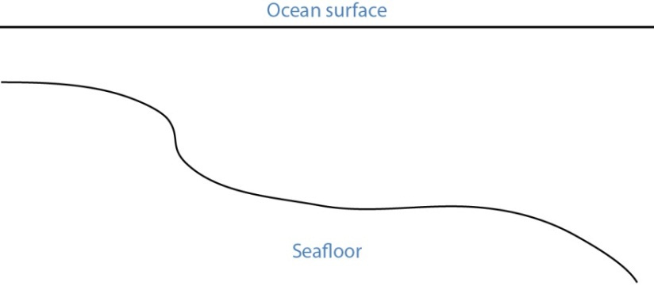
Figure 1. Barotropic model – single velocity top to bottom.
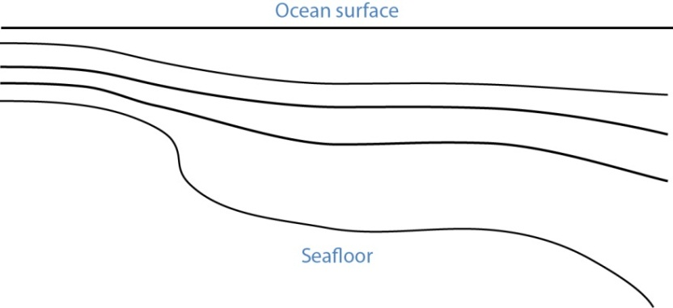
Figure 2. Sigma model – uniform number of layers, thickness scales to total depth.
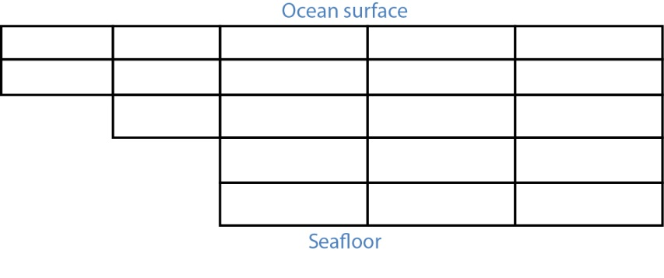
Figure 3. Gridded model – number of layers and layer thickness may vary from place to place.
[MAXNUMDEPTHS] gives the maximum number of depth points where horizontal currents are available. In some cases, points within the model may have fewer defined depth points than this number. The sigma model, however, must have data for MAXNUMDEPTHS in the water column at every horizontal point. The layered model has data at a maximum of MAXNUMDEPTHS in the water column for any horizontal point. The default is 1, which corresponds to surface data only and is the case for both the 2-D and barotropic grid types. (Though the latter has depth, it only has one unique current value per horizontal point.)

The Point Definition Block
The “POINT DEFINITION BLOCK” describes the area covered by the model, including all of the horizontal points where data are available and at which depths the information is specified. This part of the model description also completely defines the topological characteristics of the model domain by specifying the boundary segments that divide the region into “inside” and “outside” portions.
The first line in the POINT DEFINITION BLOCK is made up of the keyword “Vertices”, followed by the total number of horizontal points and the number of land points, separated by white space.
[USERDATA] is a reserved word that can be used (repeatedly, if necessary) by the developer of the PTCUR data to record any type of text documentation or metadata that they want to keep associated with the file. This is optional and can be thought of as a comment area in the file format.
Vertices NPTs NumLandPts
The fields are defined as follows:
NPTs - Gives the total number of horizontal data points (boundary and inside vertices).
NumLandPts - If data are available at all the horizontal points, this is zero. If there is a separate outer boundary from a land map where current data are not available (assumed to be zero there), the number of these boundary points is given.
The next NPTs lines of the POINT DEFINITION BLOCK define the individual horizontal points where data are available. Each line describes a single data point with the following fields, separated by white space.
Pt# Longitude Latitude depth d1 d2 … dNdepths
Each of the fields is defined as follows:
Pt# - A sequence number, or line number, assigned to each point 1…NPts.
Longitude - The latitude of the point, given in decimal degrees ranging from -180 to 180. The Western hemisphere is by convention negative latitude.
Latitude - The longitude of the point, given in decimal degrees ranging from -90 to 90. The Northern hemisphere is by convention positive longitude.
depth - The depth in meters of the modeled ocean at the point. If the grid-type is 2-D, this field and the rest of the line will not be read.
d1 d2 … dNdepths - Each of the d1 through dNdepths values will be interpreted as a depth within the water column where current information will be defined. If the grid-type is barotropic, these points will not be read and the currents that are given will be assumed to represent the entire water column. For any point where data are available at fewer than the maximum number of depths, the user should enter, in order, all the valid depths and end the line with -1 to mark the end of data.
The lines that represent data points have two restrictions on the order in which they are entered into the file:
- All boundary segments must be at the beginning of the file
- All boundary segments must have their points entered sequentially in “counter-clockwise” (CC) order.
  - CC order is defined as follows: If an observer were to travel along the boundary of the model in a direction such that his/her left hand always pointed to the inside of the model, then they would encounter the boundary points in CC order.
  - To build a PTCUR file, the user would first enter all of the points in CC order around the outer boundary of the model and follow those by the points in CC order around all the islands (in this case, only one). After the boundary segments are entered in the point list, all other points (the interior ones) can be entered in any order that is convenient.
After a line is entered for each of the model’s horizontal data points, the next line contains a single integer value:
Number_of_Boundary_Segments
This is the total number of boundary segments that are needed to define the inside/outside of the model. The first boundary listed is the main outer edge of the model; then each of the islands represented by the model is added. For example, a domain with no islands will have a value of “1”, while a domain with two islands will have a value of “3”.
Following the line that tells GNOME how many boundary segments there are in the model domain will be one line for each of the boundary segments, with the number of the last boundary point on the corresponding segment.
Last_point_in_segment1
Last_point_in_segment2
…

You may want to define the land/water map from the vertices of your domain. This may be preferable to using a high resolution shoreline if your model and the shoreline have significant mismatch. In order to define the map, you need to specify if any of the segments are open water.
WaterBoundaries 2 5
3
4
The numbers in the header line are the number of water boundaries and the total number of boundaries. The listed points are the indices of the end-points of the water boundary segments.

The Topology Block – Optional
From the POINT DEFINITION BLOCK, GNOME will be able to completely reconstruct the topology and geometry of the model domain and develop an interpolation procedure to estimate data between the specified data points. GNOME will also be able to calculate when a pollutant particle has encountered a boundary of the model domain.
Alternatively, the CATS program can be used to determine the topology. The POINT DEFINITION BLOCK is in similar form to a vertex data (VerDat) file and can easily be transformed to one. To do this:
- create a separate file with a header line “DOGS”,
- then all the points, comma delimited, followed by a line of zeros, and
- finally the boundary information.
Any depth information should be removed and a single z value included for each point (≥1.0). The order of the points in the PTCUR file must be the same as those in the VerDat file used in CATS. You can then create a fake current pattern, and export the .CUR file. Select the Topology and DAGtree blocks from a CATS .CUR file and paste them into your PTCUR file. (The DAGtree is optional. If GNOME doesn’t find a DAGtree, it will create it from the topology.) Then GNOME won’t have to perform triangularization, which saves time if the same topology will be used repeatedly with different data sets. GNOME will ignore the velocity information given at the end of each topology line from the CATS .CUR file. For more information on using CATS to transform a POINT DEFINITION BLOCK to a VerDat file, see the CATS-specific documentation.

The Time-Specific Data Blocks
The TIME SPECIFIC DATA BLOCK contains the actual current velocity data for a fixed current pattern. If the input data represent a time-stepping pattern, then the block will be repeated as many times as necessary to step through the input information.
The first line in the TIME SPECIFIC DATA BLOCK is the keyword [TIME], followed by the time at which the block of current data was taken.
[TIME] StartDay StartMo StartYr StartHr StartMin
The last five fields on this line define the time when the data in the following data block were taken. If these fields have the default value “-1” in them, it will indicate that the model data represent a steady state and that only one TIME SPECIFIC DATA BLOCK will be present.
The next NPTs lines of data in the POINT DEFINITION BLOCK give the current data for each of the points described in the POINT DEFINITION BLOCK. The line of data contains:
Pt# Ud1 Vd1 Ud2 Vd2 … UdNdepths VdNdepths
The number of U-V pairs that are given on each line will need to correspond to the data given in the POINT DEFINITION BLOCK. For example, if four different depth data points are specified for a particular point, then four U-V pairs will be expected. This means that different lines of data may be of different lengths, but they will all end with a return sequence, and the actual number of fields for a particular point will be given by the line defining that point in the POINT DEFINITION BLOCK.
If the TIME SPECIFIC DATA BLOCK does not start with a constant time flag, then it may be followed by another TIME SPECIFIC DATA BLOCK, which is in the same format, but will have a different time. Each succeeding time block must have a time value that is larger than the one from the previous block. The offsets can vary in size, though.
For very large data sets, where having all the currents in one file would be unwieldy (for example, small time-steps or extended time runs, as in Trajectory Analysis Planner [TAP]), there is an alternative format. The [TIME] blocks can be put in separate files, with any number of blocks in each file. In place of these blocks in the header file, the full file path names (or partial paths, relative to the GNOME folder), and the start-time and end-time contained in each file should be listed. The keywords for this are [FILE], [STARTTIME], and [ENDTIME]. If there is a single time in a file, the start-time and end-time are the same. A constant current can also be done this way; start-time and end-time are both a series of negative ones (“-1”).
Three annotated example files follow, each starting at the top of a page for easier reading. At this time, only 2-D time-dependent (x,y,t) data are shown in the examples.

Example 1 – Filename: skipptcur.cur
[FILETYPE] PTCUR
[NAME] skip_ps_ptcur2D
[CURSCALE] 2.0
[UNCERTALONG] .3052
[UNCERTCROSS] .127
[UNCERTMIN] .01
[MAXNUMDEPTHS] 1
[GRIDTYPE] 2-D
[USERDATA] hi fred
[USERDATA]how are you ?
VERTICES 5056 3150
1 -122.548000 47.588500 1.000
2 -122.547000 47.585500 1.000
3 -122.548000 47.581300 1.000
4 -122.547000 47.578700 1.000
5 -122.543000 47.578200 1.000
6 -122.544000 47.576000 1.000
7 -122.546000 47.574000 1.000
8 -122.549000 47.572400 1.000
9 -122.550000 47.570600 1.000
10 -122.545000 47.568500 1.000
. . .
. . .
5054 -122.447000 47.582600 1.000
5055 -122.437000 47.583300 1.000
5056 -122.427000 47.583600 1.000
Topology 6986
4 5045 5046 4162 2612 2613 -2.536220 3.269671
2 3 4 -1 2 -1 0.662334 0.724430
4 1 2 -1 1 2612 1.187206 0.244548
5 10 5045 8 2613 7 -0.668295 1.037525
6 9 10 -1 7 6 -0.174680 -0.246778
7 8 9 -1 6 -1 -0.130291 -0.090753
. . .
. . .
4958 4942 4959 6981 6975 6960 -0.899112 5.741174
4442 4441 4419 6922 6966 6985 0.818613 0.580789
4420 4421 4442 6969 6966 6967 0.626956 0.418461
4442 4461 4441 6980 6983 6970 0.641757 0.720018
DAGTree 15270
34236 1 7758
10448 2 3922
32803 3 1906
23762 4 1005
13772 5 492
34118 6 260
. . .
. . .
2448 -8 -8
2455 15268 15269
2454 -8 -8
2466 -8 -8
[TIME] 14 2 00 10 00 Day Month Year Hour Minute
0.889853 0.737729
2.14009 1.90379
2.84519 2.40390
2.84138 2.89028
2.33662 3.00912
0.0381742 1.07280
1.23144 2.63017
1.02648 2.13573
. . .
-1.96154 9.09004
1.30358 -7.58093
0.697695 -6.05114
[TIME] 14 2 00 11 00 Day Month Year Hour Minute
0.605738 0.502185
1.38961 1.23618
0.982804 0.830371
-0.529060 -0.538164
-1.72646 -2.22335
0.403527 -0.554565
-1.38999 -2.69251
. . .
2.66105 -11.2783
-0.714619 3.31164
2.13874 -12.4378
-0.351095 3.04506 Velocity information ends the file

Example 2 – Filename: ptCurMap.cur
[FILETYPE] PTCUR
[NAME] PtCur : Negative currents
[CURSCALE] 2.0
[UNCERTALONG] .3052
[UNCERTCROSS] .127
[UNCERTMIN] .01
[MAXNUMDEPTHS] 1
[GRIDTYPE] 2-D
[USERDATA] comments here
[USERDATA]
Vertices 9 0
1 -124.360000 48.574744 1.000000
2 -124.959368 48.563896 1.000000
3 -125.104952 48.182896 1.000000
4 -124.534720 48.210148 1.000000
5 -124.360000 48.288996 1.000000
6 -124.702840 48.452732 97.000000
7 -124.863320 48.383372 60.000000
8 -124.739872 48.299656 102.000000
9 -124.545448 48.400108 75.000000
BoundarySegments 1
5
WaterBoundaries 2 5 (optional section to generate land water map)
3
4
[TIME] 14 2 00 10 00
0.041327 0.001107
0.079485 -0.004495
0.036132 0.002556
0.053070 0.035451
0.086580 0.005730
0.045369 0.012076
0.031629 -0.002985
0.039163 0.009258
0.023545 -0.000079
[TIME] 14 2 00 11 00
0.041327 0.001107
0.079485 -0.004495
0.036132 0.002556
0.053070 0.035451
0.086580 0.005730
0.045369 0.012076
0.031629 -0.002985
0.039163 0.009258
0.023545 -0.000079
[TIME] 14 2 00 12 00
0.041327 0.001107
0.079485 -0.004495
0.036132 0.002556
0.053070 0.035451
0.086580 0.005730
0.045369 0.012076
0.031629 -0.002985
0.039163 0.009258
0.023545 -0.000079
[TIME] 14 2 00 13 00
0.041327 0.001107
0.079485 -0.004495
0.036132 0.002556
0.053070 0.035451
0.086580 0.005730
0.045369 0.012076
0.031629 -0.002985
0.039163 0.009258
0.023545 -0.000079
[TIME] 14 2 00 14 00
0.041327 0.001107
0.079485 -0.004495
0.036132 0.002556
0.053070 0.035451
0.086580 0.005730
0.045369 0.012076
0.031629 -0.002985
0.039163 0.009258
0.023545 -0.000079
[TIME] 14 2 00 15 00
0.041327 0.001107
.079485 -0.004495
0.036132 0.002556
0.053070 0.035451
0.086580 0.005730
0.045369 0.012076
0.031629 -0.002985
0.039163 0.009258
0.023545 -0.000079
[TIME] 14 2 00 16 00
0.041327 0.001107
0.079485 -0.004495
0.036132 0.002556
0.053070 0.035451
0.086580 0.005730
0.045369 0.012076
0.031629 -0.002985
0.039163 0.009258
0.023545 -0.000079
[TIME] 14 2 00 17 00
0.041327 0.001107
0.079485 -0.004495
0.036132 0.002556
0.053070 0.035451
0.086580 0.005730
0.045369 0.012076
0.031629 -0.002985
0.023545 -0.000079
0.027216 0.003247

Example 3 – Filename: ptCurNoMap.cur
[FILETYPE] PTCUR
[NAME] PtCur : Negative currents
[CURSCALE] 2.0
[UNCERTALONG] .3052
[UNCERTCROSS] .127
[UNCERTMIN] .01
[MAXNUMDEPTHS] 1
[GRIDTYPE] 2-D
[USERDATA] comments here
Vertices 9 0
1 -124.360000 48.574744 1.000000
2 -124.959368 48.563896 1.000000
3 -125.104952 48.182896 1.000000
4 -124.534720 48.210148 1.000000
5 -124.360000 48.288996 1.000000
6 -124.702840 48.452732 97.000000
7 -124.863320 48.383372 60.000000
8 -124.739872 48.299656 102.000000
9 -124.545448 48.400108 75.000000
BoundarySegments 1
5 (Note that the Water Boundaries section is missing)
[TIME] 14 2 00 10 00
0.041327 0.001107
0.079485 -0.004495
0.036132 0.002556
0.053070 0.035451
0.086580 0.005730
0.045369 0.012076
0.031629 -0.002985
0.039163 0.009258
0.023545 -0.000079
[TIME] 14 2 00 11 00
0.041327 0.001107
0.079485 -0.004495
0.036132 0.002556
0.053070 0.035451
0.086580 0.005730
0.045369 0.012076
0.031629 -0.002985
0.039163 0.009258
0.023545 -0.000079
[TIME] 14 2 00 12 00
0.041327 0.001107
0.079485 -0.004495
0.036132 0.002556
0.053070 0.035451
0.086580 0.005730
0.045369 0.012076
0.031629 -0.002985
0.039163 0.009258
0.023545 -0.000079
[TIME] 14 2 00 13 00
0.041327 0.001107
0.079485 -0.004495
0.036132 0.002556
0.053070 0.035451
0.086580 0.005730
0.045369 0.012076
0.031629 -0.002985
0.039163 0.009258
0.023545 -0.000079
[TIME] 14 2 00 14 00
0.041327 0.001107
0.079485 -0.004495
0.036132 0.002556
0.053070 0.035451
0.086580 0.005730
0.045369 0.012076
0.031629 -0.002985
0.039163 0.009258
.023545 -0.000079
[TIME] 14 2 00 15 00
0.041327 0.001107
0.079485 -0.004495
0.036132 0.002556
0.053070 0.035451
0.086580 0.005730
0.045369 0.012076
0.031629 -0.002985
0.039163 0.009258
0.023545 -0.000079
[TIME] 14 2 00 16 00
0.041327 0.001107
0.079485 -0.004495
0.036132 0.002556
0.053070 0.035451
0.086580 0.005730
0.045369 0.012076
0.031629 -0.002985
0.039163 0.009258
0.023545 -0.000079
[TIME] 14 2 00 17 00
0.041327 0.001107
0.079485 -0.004495
0.036132 0.002556
0.053070 0.035451
0.086580 0.005730
0.045369 0.012076
0.031629 -0.002985
0.023545 -0.000079
0.027216 0.003247

Currents: Rectangular Grid – Steady State [GridCur]
The GridCur file should contain velocity information in the x and y directions on a rectangular grid. The first eight lines contain header information that defines the file type, grid size, and grid location. The remaining lines contain the current data. The keywords are the words shown in capital letters below. They must appear exactly as shown. This documentation consists of two example files followed by an explanation of each of the file components. You can set the range of the data by providing:
- the upper left corner position and the increment size of $Δ_{x}$ and $Δ_{y}$, or
- the bounding latitude and longitude box.
If you would like to try either of these current patterns, you will also need the GridCur.bna file.
Note: If you have missing values, you may simply skip those grid points in the data file.

Example 1 – Filename: GridCurExA.cur
In this first example, GridCurExA.cur, position information is given from a starting latitude and longitude and an increment.
[GRIDCUR]
NUMROWS 100
NUMCOLS 100
STARTLAT 33.8
STARTLONG -120.4
DLAT .008
DLONG .01
row col u v
1 1 .10 .10
1 2 .10 .10
1 3 .10 .10
1 4 .10 .10
1 5 .10 .10
1 6 .10 .10
. . .

Example 2 – Filename: GridCurExB.cur
In this second example, GridCurExB.cur, the grid location is given by bounding latitudes and longitudes.
[GRIDCUR]
NUMROWS 100
NUMCOLS 100
LOLAT 33.4
HILAT 35
LOLONG -120.4
HILONG -119
row col u v
1 1 .10 .10
1 2 .10 .10
1 3 .10 .10
1 4 .10 .10
1 5 .10 .10
. . .

Explanation of File Components
The first line of the file is a flag identifying the file as an outside current file:
NUMROWS nrows
NUMCOLS ncols
Lines 4 through 7 give the grid bounds and can be specified in either of two ways:
- By the latitude and longitude of the grid origin (assumed to be the upper-left corner) and the increment size:
STARTLAT lat
STARTLON long
DLAT dlat
DLONG dlong
- By low and high latitude and longitude ranges:
LOLAT lolat
HILAT hilat
LOLONG lolong
HILON hilong
In the former case, the velocities are assumed to be given at the grid points, and in the latter case, the velocities are assumed to be in the center of grid rectangles.
Line 8 is designed to be a header, identifying the columns of data. It is read, but not used.
row col u v
This header information is followed by NROWS × NCOLS lines of current data. Each line consists of 4 elements, corresponding to the items in Line 8. These are the point’s location in the grid, given by a row and column, and its velocity components in the x and y directions, assumed to be in m s⁻¹. The file must contain a line for each of the NROWS × NCOLS grid points.

Currents: Rectangular Grid – Time Dependent [GridCurTime]
If you have a rectangular grid time-dependent model, you can use this data format to create the time-series of currents for GNOME. Large models and/or long time-series can produce large files of output fields. You have the option to store all your data in one file, or in a series of files. We have been successful in obtaining daily forecasts in separate files, archiving them, and then “stringing” them together to create a time-series for a single incident.

Data in a Single File
GNOME accepts rectangular grid models in a simple file format, similar to the single current pattern described above. The header now indicates with [GRIDCURTIME] that time has been added, and the time of the first time-step has been given in the [TIME] line.
Note: As in the rectangular GridCur data format, if you have missing values, you may simply skip those grid points in the data file. You may also create a constant current pattern by setting all the time references to -1.

Example – Filename: gridcurTime.cur
[GRIDCURTIME]
NUMROWS 100
NUMCOLS 100
LOLAT 34.0
HILAT 34.4
LOLONG -120.8
HILONG -119.2
[TIME] 14 2 00 10 00 day month year hour minute
1 1 .10 .10
1 2 .10 .10
1 3 .10 .10
1 4 .10 .10
…
Each succeeding time-step is simply appended onto the bottom:
…
100 97 .10 .10
100 98 .10 .10
100 99 .10 .10
100 100 .10 .10
[TIME] 14 2 00 11 00 next timestep information
1 1 .20 .20
1 2 .20 .20
1 3 .20 .20
1 4 .20 .20
1 5 .20 .20
1 6 .20 .20

Data in Multiple Files
With larger time-series of current data, it may be useful to break the current time-series into separate files that make up a long time-series all together. In that case, GNOME supports multi-file data with a header file that indicates data and hard drive location information, and the subsequent files. The format is similar to the header on the regular GridCurTime format; however, rather than including the time information and the data, this header includes the file name and location, and the start and end times for each of the files. GNOME uses linear interpolation between time-steps within and across files. The references to the locations of the different current files on the computer’s hard drive can be given two ways: a full path description of the directory or a relative description of the directory.
Note: A constant current can be created using a single record with all the time indicators set to -1. A single time-step is acceptable in a file with the start and end times listed as the same time in the header file.
The following four files are provided as examples with full path descriptions:
gridcurtime_hdr.cur
gridcurtime_hdrA.cur
gridcurtime_hdrB.cur
gridcurtime_hdrC.cur

Example 1 – Filename: gridcurtime_hdr.cur
The first file, gridcurtime_hdr.cur, contains the header information, and the three subsequent files comprise the data.
[GRIDCURTIME]
NUMROWS 78
NUMCOLS 92
LOLAT 34.
HILAT 34.4
LOLONG -120.8
HILONG -119.2
[FILE] C:\GridCurTime\gridcurtime_hdrA.cur
[STARTTIME] 30 1 2002 1 0
[ENDTIME] 30 1 2002 2 0
[FILE] C:\GridCurTime\gridcurtime_hdrB.cur
[STARTTIME] 30 1 2002 3 0
[ENDTIME] 30 1 2002 5 0
[FILE] C:\GridCurTime\gridcurtime_hdrC.cur
[STARTTIME] 30 1 2002 6 0
[ENDTIME] 30 1 2002 8 0

Example 2 – Filenames: gridcurtime_hdrA.cur, gridcurtime_hdrB.cur, and gridcurtime_hdrC.cur
In the next example, the paths start with a colon (:), to indicate that they are relative paths.
[GRIDCURTIME]
NUMROWS 78
NUMCOLS 92
LOLAT 34
HILAT 34.4
LOLONG -120.8
HILONG -119.2
[FILE] :gridcurtime_hdrA.cur
[STARTTIME] 30 1 2002 1 0
[ENDTIME] 30 1 2002 2 0
[FILE] :gridcurtime_hdrB.cur
[STARTTIME] 30 1 2002 3 0
[ENDTIME] 30 1 2002 5 0
[FILE] :gridcurtime_hdrC.cur
[STARTTIME] 30 1 2002 6 0
[ENDTIME] 30 1 2002 8 0
Each subsequent file contains only the data, with no header information:
[TIME] 30 1 2002 1 0
1 1 0.00000 0.00000
1 2 0.00000 0.00000
1 3 0.00000 0.00000
1 4 0.00000 0.00000
1 5 0.00000 0.00000
1 6 0.00000 0.00000
1 7 0.00000 0.00000
1 8 0.00000 0.00000
1 9 0.00000 0.00000
1 10 0.00000 0.00000
1 11 0.00000 0.00000

NetCDF Formats
Currently, GNOME can read in NetCDF files for rectangular, curvilinear, and triangular grids. This section includes examples of the three formats currently in use and some descriptions of the required information. Please note that the NetCDF formats described here are presently undergoing revision to conform to the newly forming Climate & Forecast unstructured grid data model, to be adopted in future releases of GNOME.

NetCDF Rectangular Grid
Below is an example of the regular grid format for NetCDF files. The global attribute grid_type = REGULAR is the default. Time units can be hours, minutes, seconds, or days. A separate map will be needed in order to set a spill.
NetCDF MacintoshHD:Desktop Folder:test {
dimensions:
lat = 16 ;
lon = 20 ;
time = UNLIMITED ; (85 currently)
variables:
double lat(lat) ;
lat:long_name = "Latitude" ;
lat:units = "degrees_north" ;
lat:point_spacing = "even" ;
double lon(lon) ;
lon:long_name = "Longitude" ;
lon:units = "degrees_east" ;
lon:point_spacing = "even" ;
double time(time) ;
time:long_name = "Valid Time" ;
time:units = "minutes since 1999-11-25 00:00:00" ;
float water_u(time, lat, lon) ;
water_u:long_name = "Eastward Water Velocity" ;
water_u:units = "m/s" ;
water_u:_FillValue = -9.9999e+32f ;
water_u:scale_factor = 1.f ;
water_u:add_offset = 0.f ;
float water_v(time, lat, lon) ;
water_v:long_name = "Northward Water Velocity" ;
water_v:units = "m/s" ;
water_v:_FillValue = -9.9999e+32f ;
water_v:scale_factor = 1.f ;
water_v:add_offset = 0.f ;

global attributes:
:grid_type = "REGULAR" ;
data:

lat = 51.144606, 51.234386, 51.324167, 51.413944, 51.503722, 51.5935,
51.683275, 51.77305, 51.862825, 51.952594, 52.042364, 52.132133, 52.2219,
52.311664, 52.401425, 52.491186 ;

lon = 2.3155722, 2.4583139, 2.6010833, 2.743875, 2.8866917, 3.0295306,
3.1723917, 3.3152694, 3.4581667, 3.6010833, 3.7440139, 3.8869583,
4.0299167, 4.1728861, 4.3158667, 4.4588583, 4.6018583, 4.7448639,
4.887875, 5.0308917 ;

time = 7020, 7080, 7140, 7200, 7260, 7320, 7380, 7440, 7500, 7560, 7620,
7680, 7740, 7800, 7860, 7920, 7980, 8040, 8100, 8160, 8220, 8280, 8340,
8400, 8460, 8520, 8580, 8640, 8700, 8760, 8820, 8880, 8940, 9000, 9060,
9120, 9180, 9240, 9300, 9360, 9420, 9480, 9540, 9600, 9660, 9720, 9780,
9840, 9900, 9960, 10020, 10080, 10140, 10200, 10260, 10320, 10380, 10440,
10500, 10560, 10620, 10680, 10740, 10800, 10860, 10920, 10980, 11040,
11100, 11160, 11220, 11280, 11340, 11400, 11460, 11520, 11580, 11640,
11700, 11760, 11820, 11880, 11940, 12000, 12060 ;

NetCDF Curvilinear Grid
Below is an example of the curvilinear format for NetCDF files. The global attribute grid_type = CURVILINEAR is required (the default is grid_type = REGULAR). In addition to x and y, there are several other dimension name options for latitude and longitude. The dimension names only need to start with X, Y or LAT, LON to be recognized. The variable names must appear as shown. The velocities can be short, float, or double precision numbers. Time units can be hours, minutes, seconds, or days. The land-mask is required if you want to use the grid boundary as the shoreline: 0 is land, 1 is water. If no map is available, the mask is used to identify land points (land = 0, water = 1) and a boundary map is created. The first sigma value is used, though currently GNOME is being extended to handle 3-D currents. The topology can be saved out the first time and reloaded.
netcdf 20040726_11z_HAZMAT {
dimensions:
x = 73 ;
y = 163 ;
sigma = 3 ; optional
time = UNLIMITED ; (12 currently)
variables:
float time(time) ;
time:long_name = "Time" ;
time:base_date = 2004, 1, 1, 0 ;
time:units = "days since 2004-01-01 0:00:00 00:00" ;
time:standard_name = "time" ;
float lon(y, x) ;
lon:long_name = "Longitude" ;
lon:units = "degrees_east" ;
lon:standard_name = "longitude" ;
float lat(y, x) ;
lat:long_name = "Latitude" ;
lat:units = "degrees_north" ;
lat:standard_name = "latitude" ;
float mask(y, x) ;
mask:long_name = "Land Mask" ;
mask:units = "nondimensional" ;
float depth(y, x) ; optional
depth:long_name = "Bathymetry" ;
depth:units = "meters" ;
depth:positive = "down" ;
depth:standard_name = "depth" ;
float sigma(sigma) ; optional
sigma:long_name = "Sigma Stretched Vertical Coordinate at Nodes" ;
sigma:units = "sigma_level" ;
sigma:positive = "down" ;
sigma:standard_name = "ocean_sigma_coordinate" ;
sigma:formula_terms = "sigma: sigma eta: zeta depth: depth" ;
float u(time, sigma, y, x) ;
u:long_name = "Eastward Water Velocity" ;
u:units = "m/s" ;
u:missing_value = -99999.f ;
u:_FillValue = -99999.f ;
u:standard_name = "eastward_sea_water_velocity" ;
float v(time, sigma, y, x) ;
v:long_name = "Northward Water Velocity" ;
v:units = "m/s" ;
v:missing_value = -99999.f ;
v:_FillValue = -99999.f ;
v:standard_name = "northward_sea_water_velocity" ;

global attributes:
:file_type = "Full_Grid" ;
:Conventions = "COARDS" ;
:grid_type = "curvilinear" ;
:z_type = "sigma" ;
:model = "POM" ;
:title = "Forecast: wind+tide+river" ;
data:

time = 208.4688, 208.4792, 208.4896, 208.5, 208.5104, 208.5208, 208.5312,
208.5417, 208.5521, 208.5625, 208.5729, 208.5833,,;

sigma = 0, .5, 1.;
}

NetCDF Triangular Grid

Example – Triangular Grid Format with Velocities on the Nodes
Below is an example of the triangular grid format for NetCDF files with velocities on the nodes. The global attribute grid_type = TRIANGULAR is required (the default is grid_type = REGULAR). The first depth value is used. Time units can be hours, minutes, seconds, or days. A map will be created using the boundary data. The topology can be saved out the first time and reloaded.
The NetCDF header description for finite element model:
NetCDF MacintoshHD:Desktop Folder:testFile {
dimensions:
node = 7258 ;
nele = 13044 ; not currently used
nbnd = 1476 ;
nbi = 4 ;
sigma = 11 ; optional
time = UNLIMITED ; (12 currently)
variables:
short bnd(nbnd, nbi) ;
bnd:long_name = "Boundary Segment Node List" ;
bnd:units = "index_start_1" ;
float time(time) ;
time:long_name = "Time" ;
time:units = "days since 2003-01-00 0:00:00 00:00" ;
time:base_date = 2003, 1, 0, 0 ;
float lon(node) ;
lon:long_name = "Longitude" ;
lon:units = "degrees_east" ;
float lat(node) ;
lat:long_name = "Latitude" ;
lat:units = "degrees_north" ;
float sigma(sigma) ; optional
sigma:long_name = "Stretched Vertical Coordinate" ;
sigma:units = "sigma_level" ;
sigma:positive = "down" ;
float u(time, sigma, node) ;
u:long_name = "Eastward Water Velocity" ;
u:units = "m/s" ;
u:missing_value = -99999.f ;
u:_FillValue = -99999.f ;
float v(time, sigma, node) ;
v:long_name = "Northward Water Velocity" ;
v:units = "m/s" ;
v:missing_value = -99999.f ;
v:_FillValue = -99999.f ;

global attributes:
:file_type = "FEM" ;
:Conventions = "COARDS" ;
:grid_type = "Triangular" ;
data:

time = 26.95833, 27, 27.04167, 27.08333, 27.125, 27.16667, 27.20833, 27.25,
27.29167, 27.33333, 27.375, 27.41667 ;

sigma = 1, 0.9807215, 0.9306101, 0.83061, 0.6807215, 0.5, 0.3192785,
0.1693899, 0.06938996, 0.01927857, 0 ;
}
Notes:
- The boundary list is an array of dimension bnd(nbnd, 4). It consists of node numbers of the line segments, with a digit to indicate which land or island the segment is a part of, and a digit to indicate whether a boundary is land or water:
node1 | node2 | island | land/water (0/1)
1 | 2 | 0 | 0 | 1 is usually the continent and outer water BC
2 | 5 | 0 | 0
5 | 23 | 0 | 1
…
3568 | 1 | 0 | 1 | The last segment joins up with the first.
551 | 552 | 1 | 0 | next island
552 | 567 | 1 | 0
…
677 | 551 | 1 | 0
789 | 388 | 2 | 0
… |  |  |  | next island, etc.
- Only the first sigma level is used, although GNOME is currently being extended to handle 3-D currents.

Example – Triangular Grid Format with Velocities on the Triangles
Following is an example of the triangular grid format for NetCDF files with velocities on the triangles. The global attribute grid_type = TRIANGULAR is required (the default is grid_type = REGULAR). The first depth value is used. Time units can be hours, minutes, seconds, or days. A map will be created using the boundary data. The topology must be included in the file.
netcdf FVCOM_example {
dimensions:
node = 32649 ;
nele = 60213 ;
nbnd = 5099 ;
nbi = 4 ;
time = UNLIMITED ; // (1 currently)
three = 3 ;
variables:
int bnd(nbnd, nbi) ;
float time(time) ;
time:units = "days since 1978-11-17 00:00:00 0:00" ;
time:long_name = "time" ;
time:time_zone = "UTC" ;
time:format = "modified julian day (MJD)" ;
float lon(node) ;
float lat(node) ;
float u(time, nele) ;
u:units = "meters s-1" ;
u:long_name = "Eastward Water Velocity" ;
u:grid = "fvcom_grid" ;
u:type = "data" ;
float v(time, nele) ;
v:units = "meters s-1" ;
v:long_name = "Northward Water Velocity" ;
v:grid = "fvcom_grid" ;
v:type = "data" ;
int nbe(three, nele) ;
int nv(three, nele) ;

// global attributes:
:grid_type = "Triangular" ;
data:

time = 11452 ;
}
Notes:
- The boundary list is an array of dimension bnd(nbnd, 4), same as above.
- The triangle vertices are contained in nv and the neighboring triangles in nbe.

Data in Multiple NetCDF Files: When Your NetCDF Files Start To Get Too Big
Longer simulations require more model data, and that can cause problems with putting the entire time-series into one data file. GNOME allows you to break the time-series into separate files using a master file to identify all the pieces of the time-series in order. This also makes possible using a series of nowcasts and forecasts strung together to make a times-series. This technique worked well during the 2002 T/V Prestige incident in Spain.
First create a text master file with the list of file path-names (relative to the GNOME directory) in order. Next supply the full path name if the files are not in the same directory as GNOME, or in a subdirectory. The file will also need a header line, “NetCDF Files”.
When you go to load the currents in GNOME, load your master file (e.g., §1.2.2.4.1 Example 1 – Filename: MyMasterFileEx.txt). GNOME will use this as the list of files for the time-series.

Example 1 – Filename: MyMasterFileEx.txt
NetCDF Files
[FILE] :day1.nc
[FILE] :day2.nc
[FILE] :day3.nc
[FILE] :day4.nc
[FILE] :day5.nc
[FILE] :day6.nc

Scaling Current Patterns
Since the current patterns created in CATS only indicate the direction of the current and the relative speeds, these current patterns need to be scaled in order to be useful with the trajectory model. For example, consider a fictitious current pattern with only two triangles, A and B. The velocity in triangle A is 1.2 to the east and the velocity in triangle B is 1.8 to the north. Observations indicate that the velocity in triangle A should be 3.0 knots to the east, so we must scale the current pattern by the ratio of these velocities in triangle A, or (3.0 knots ÷ 1.2 = 2.5 knots). That is, multiplying the velocity in triangle A in the current pattern (1.2) by the scale factor (2.5 knots) yields the observed velocity (3.0 knots). The direction did not change. To find the velocity in triangle B, we multiply the velocity in triangle B in the current pattern (1.8) by the scale factor (2.5 knots) to get a velocity of 4.5 knots. The velocity in triangle B is still to the north, since the direction does not change in the current pattern.
GNOME is quite helpful in scaling current patterns. At a given reference point in the current pattern, GNOME tells you what the flow is. You then input into GNOME what you would like the velocity to be at the reference point, and GNOME calculates the scaling coefficient for the pattern for you!
The direction of the flow in the current fields in GNOME can reverse by multiplying the pattern by a negative scaling coefficient. The ebb and flow of tides are simulated this way, through a time-series of positive and negative scaling values. You can scale currents with either a constant value or a time-series. The acceptable file formats for time-series are outlined below.

Time-Series File Formats
Current patterns in GNOME can be scaled to be time dependent with two different file types:
- a time-series of current magnitude or
- a “SHIO mover” that contains data for GNOME to use in calculating tidal current magnitudes.
All data in this section were created by the NOAA SHIO application (“shio” comes from Japanese for “tide”).
The South Bend, Washington, U.S.A. station on the Willapa River was chosen for all the examples in this section. Below is the information found in the SouthBend.text file to illustrate the information GNOME needs in order to calculate the tidal currents at this station. This particular file is not a data file for GNOME. Those data are represented in data files presented later in this discussion.

Example – Filename: SouthBend.text
Tidal currents at South Bend, Willapa River, WASHINGTON COAST
Station No. CP1009
Meter Depth: n/a

Latitude: 46˚0' N
Longitude: 123˚47' W

Maximum Flood Direction: 90˚
Maximum Ebb Direction: 270˚

Time offsets Hour:Min
Min Before Flood 0:19am
Flood 0:20am
Min Before Ebb 0:24am
Ebb -0:06am

Flood Speed Ratio: 0.6
Ebb Speed Ratio: 0.5

 | Speed(kt) | Direction(deg.)
Min Before Flood | 00.0 | n/a
Flood | 01.2 | 090
Min Before Ebb | 00.0 | n/a
Ebb | 01.4 | 270

Based on Grays Harbor Ent.

Local Standard Time

------------------------------------------------------------------
Mon, Aug 24, 1998--Sunrise -- 6:09am Sunset -- 7:55pm
0:38am +01.2 Max Flood
3:31am +00.0 Min Before Ebb
6:29am -01.6 Max Ebb
9:59am +00.0 Min Before Flood
1:08pm +01.4 Max Flood
4:12pm +00.0 Min Before Ebb
6:56pm -01.4 Max Ebb
10:17pm +00.0 Min Before Flood

Time Series of Current Magnitude
Time series file for currents have the format
dd,mm,yy,hr,min,$\left|U\right|$,0.0
where dd is the day, mm is the month, yy is the year, hr is the hour, min is the minute, $\left|U\right|$ is the magnitude of the velocity, and 0.0 is a number to indicate that the file is in a magnitude format rather than a U,V format. The direction is left blank because the current pattern supplies the individual current vectors. There is an optional header –
- The first line lists the station name.
- The second line lists the station position.
- The third line provides the units.
For example, the SouthBend.ossm file contains one day of tidal information for South Bend, Washington, U.S.A.

Example – Filename: SouthBend.ossm
South Bend
-123.78,46
knots
24, 8, 98, 0, 37, 1.2, 0.0
24, 8, 98, 3, 30, 0.0, 0.0
24, 8, 98, 6, 28, -1.6, 0.0
24, 8, 98, 9, 58, 0.0, 0.0
24, 8, 98, 13, 7, 1.4, 0.0
24, 8, 98, 16, 11, 0.0, 0.0
24, 8, 98, 18, 55, -1.4, 0.0
24, 8, 98, 22, 16, 0.0, 0.0

Annotated Version of the File
Day, | Month, | Year, | Hour, | Min., | Speed, | Direction (Dummy Value)
24, | 8, | 98, | 0, | 37, | 1.2, | 0.0
24, | 8, | 98, | 3, | 30, | 0.0, | 0.0
24, | 8, | 98, | 6, | 28, | -1.6, | 0.0
24, | 8, | 98, | 9, | 58, | 0.0, | 0.0
24, | 8, | 98, | 13, | 7, | 1.4, | 0.0
24, | 8, | 98, | 16, | 11, | 0.0, | 0.0
24, | 8, | 98, | 18, | 55, | -1.4, | 0.0
24, | 8, | 98, | 22, | 16, | 0.0, | 0.0

SHIO Movers: Using Tidal Constituents
GNOME can use both tidal height and tidal current constituent data to scale current patterns. In the case of tidal height station data (§1.2.3.1.3.1, below), GNOME will take the time derivative of the tidal heights, and request the user to scale that derivative to calculate the tidal currents. For the tidal current station data (§1.2.3.1.3.2, below), GNOME will use the calculated currents directly. The constituent record data are rather complex, so we have provided information about the data fields and then provided an example file.

Tidal Heights Constituent Record
Line 1 [StationInfo]
Line 2 Type=H station type for heights is “H”
Line 3 staName station name
Line 4 Latitude=latStr decimal degrees
Line 5 Longitude=longStr decimal degrees
Line 6 [Constituents]
Line 7 DatumControls.datum=datum mean sea level
Line 8 DatumControls.FDir=0 bug. Type as seen. Will be fixed in 1.2.7
Line 9 DatumControls.EDir=0 bug. Type as seen. Will be fixed in 1.2.7
Line 10 DatumControls.L2Flag=0 bug. Type as seen. Will be fixed in 1.2.7
Line 11 DatumControls.HFlag=0 bug. Type as seen. Will be fixed in 1.2.7
Line 12 DatumControls.RotFlag=0 bug. Type as seen. Will be fixed in 1.2.7
Lines 13-17 constituent amplitudes in order M2, S2, N2, K1, M4, O1, M6, MK3, S4, MN4, NU2, S6, MU2, 2N2, OO1, LAM2, S1, M1, J1, MM, SSA, SA, MSF, MF, RHO, Q1, T2, R2, 2Q1, P1, 2SM2, M3, L2, 2MK3, K2, M8, MS4 [feet]
Lines 18-23 constituent phases in order see above, lines 13-17 [degrees]
Line 24 [Offset]
Note: Lines 25-30 use a second integer to indicate to GNOME whether there is valid data in the field. “0” indicates no data, so GNOME can skip the calculation. “1” indicates valid data exists (that may be zero).
Line 25 HighTime=highTime 1 high water time adjustment (minutes)
Line 26 LowTime=lowTime 1 low water time adjustment
Line 27 HighHeight_Mult=highHeightScalar 1 high water height multiplier
Line 28 HighHeight_Add=highHeightAdd 1 high water height addend
Line 29 LowHeight_Mult=lowHeightScalar 1 low water height multiplier
Line 30 LowHeight_Add=lowHeightAdd 1 low water height addend

Example – Filename: HornIslandPass.shio.txt
[StationInfo]
Type=H
Name=Horn Island Pass
Latitude=30.2167
Longitude=-88.483333
[Constituents]
DatumControls.datum=0.620000
DatumControls.FDir=0
DatumControls.EDir=0
DatumControls.L2Flag=0
DatumControls.HFlag=0
DatumControls.RotFlag=0
H=0.066000 0.022000 0.013000 0.468000 0.000000 0.460000 0.000000 0.000000 0.000000 0.000000 0.000000 0.000000 0.000000 0.000000 0.020000 0.000000 0.000000 0.033000 0.036000 0.000000 0.120000 0.299000 0.000000 0.000000 0.018000 0.099000 0.000000 0.000000 0.012000 0.139000 0.000000 0.000000 0.000000 0.000000 0.000000 0.000000 0.000000 0.000000 0.000000 0.000000 0.000000 0.000000
kPrime=358.500000 355.700012 0.000000 327.000000 0.000000 324.200012 0.000000 0.000000 0.000000 0.000000 0.000000 0.000000 0.000000 0.000000 329.799988 0.000000 0.000000 325.500000 328.399994 0.000000 32.099998 151.800003 0.000000 0.000000 323.000000 314.100006 0.000000 0.000000 321.299988 331.899994 0.000000 0.000000 0.000000 0.000000 0.000000 0.000000 0.000000 0.000000 0.000000 0.000000 0.000000 0.000000
[Offset]
HighTime=-0.516667 1
LowTime=-0.883333 1
HighHeight_Mult=1.300000 1
HighHeight_Add=0.000000 1
LowHeight_Mult=1.300000 1
LowHeight_Add=0.000000 1

Tidal Currents Constituent Record
Line 1 [StationInfo]
Line 2 Type=C station type for currents is “C”
Line 3 staName station name
Line 4 Latitude=latStr decimal degrees
Line 5 Longitude=longStr decimal degrees
Line 6 [Constituents]
Line 7 DatumControls.datum=datum datum
Line 8 DatumControls.FDir=floodDirection flood direction
Line 9 DatumControls.EDir=ebbDirection ebb direction
Line 10 DatumControls.L2Flag=L2Flag L2Flag
Line 11 DatumControls.HFlag=hydraulicFlag hydraulic flag
Line 12 DatumControls.RotFlag=0 For non-rotary tides, use “0”. For rotary tides defined relative to North or East, use “1”. For rotary tides defined by major and minor axes, use “2”.
Lines 13-17 constituent amplitudes in order M2, S2, N2, K1, M4, O1, M6, MK3, S4, MN4, NU2, S6, MU2, 2N2, OO1, LAM2, S1, M1, J1, MM, SSA, SA, MSF, MF, RHO, Q1, T2, R2, 2Q1, P1, 2SM2, M3, L2, 2MK3, K2, M8, MS4 [knots]
Lines 18-23 constituent phases in order see above, lines 13-17 [degrees]
Line 24 [Offset]
Note: Lines 25-38 use a second integer to indicate to GNOME whether there is valid data in the field. “0” indicates no data, so GNOME can skip the calculation. “1” indicates valid data exists (that may be zero).
Line 25 MinBefFloodTime= minBefFloodTime 1 minimum before flood time adjustment
Line 26 FloodTime= floodTime 1 flood time adjustment
Line 27 MinBefEbbTime= minBefEbbTime 1 minimum before ebb time adjustment
Line 28 EbbTime= ebbTime 1 ebb time adjustment
Line 29 FloodSpdRatio=floodSpeedRatio 1 flood speed ratio
Line 30 EbbSpdRatio=ebbSpeedRatio 1 ebb speed ratio
Line 31 MinBFloodSpd=minBefFloodAvgSpeed 0 average speed - minimum before flood
Line 32 MinBFloodDir=minBefFloodAvgDir 0 average direction - minimum before flood
Line 33 MaxFloodSpd=maxFloodAvgSpeed 0 average speed - flood
Line 34 MaxFloodDir=maxFloodAvgDir 0 average direction - flood
Line 35 MinBEbbSpd=minBefEbbAvgSpeed 0 average speed - minimum before ebb
Line 36 MinBEbbDir=minBefEbbAvgDir 0 average direction - minimum before ebb
Line 37 MaxEbbSpd=maxEbbAvgSpeed 0 average speed – ebb
Line 38 MaxEbbDir=maxEbbAvgDir 0 average direction – ebb

Example – Filename: StJohnsRiver.shio.txt
[StationInfo]
Type=C
Name=ST. JOHNS RIVER ENT. (between jetties)
Latitude=30.400000
Longitude=-81.383333
[Constituents]
DatumControls.datum=-0.350000
DatumControls.FDir=275
DatumControls.EDir=100
DatumControls.L2Flag=0
DatumControls.HFlag=0
DatumControls.RotFlag=0
H=1.993000 0.333000 0.404000 0.216000 0.293000 0.174000 0.092000 0.000000 0.000000 0.000000 0.078000 0.000000 0.000000 0.054000 0.000000 0.014000 0.000000 0.012000 0.014000 0.000000 0.000000 0.000000 0.000000 0.000000 0.000000 0.034000 0.020000 0.000000 0.000000 0.071000 0.000000 0.000000 0.054000 0.000000 0.091000 0.044000 0.000000 0.000000 0.000000 0.000000 0.000000 0.000000
kPrime=227.199997 244.399994 208.800003 98.800003 131.100006 122.699997 238.699997 0.000000 0.000000 0.000000 211.199997 0.000000 0.000000 190.300003 0.000000 235.199997 0.000000 110.699997 86.800003 0.000000 0.000000 0.000000 0.000000 0.000000 0.000000 134.600006 244.600006 0.000000 0.000000 99.199997 0.000000 0.000000 245.699997 0.000000 244.000000 100.800003 0.000000 0.000000 0.000000 0.000000 0.000000 0.000000
[Offset]
MinBefFloodTime=0.000000 1
FloodTime=0.000000 1
MinBefEbbTime=0.000000 1
EbbTime=0.000000 1
FloodSpdRatio=1.000000 1
EbbSpdRatio=1.000000 1
MinBFloodSpd=0.000000 0
MinBFloodDir=0.000000 0
MaxFloodSpd=0.000000 0
MaxFloodDir=0.000000 0
MinBEbbSpd=0.000000 0
MinBEbbDir=0.000000 0
MaxEbbSpd=0.000000 0
MaxEbbDir=0.000000 0

Example – Filename: Edmonds.shio.txt
[StationInfo]
Type=C
Name=Edmonds, 2.7 miles WSW of
Latitude=47.800000
Longitude=-122.450000
[Constituents]
DatumControls.datum=-0.500000
DatumControls.FDir=180
DatumControls.EDir=5
DatumControls.L2Flag=0
DatumControls.HFlag=0
DatumControls.RotFlag=0
H=1.954000 0.460000 0.402000 0.847000 0.000000 0.421000 0.000000 0.000000 0.000000 0.000000 0.078000 0.000000 0.000000 0.054000 0.018000 0.013000 0.000000 0.030000 0.033000 0.000000 0.000000 0.000000 0.000000 0.000000 0.016000 0.081000 0.028000 0.000000 0.000000 0.280000 0.000000 0.000000 0.055000 0.000000 0.125000 0.000000 0.000000 0.000000 0.000000 0.000000 0.000000 0.000000
kPrime=66.400002 84.099998 39.400002 72.500000 0.000000 66.199997 0.000000 0.000000 0.000000 0.000000 43.000000 0.000000 0.000000 12.300000 78.800003 74.599998 0.000000 69.300003 75.800003 0.000000 0.000000 0.000000 0.000000 0.000000 63.500000 63.000000 84.400002 0.000000 0.000000 73.199997 0.000000 0.000000 93.400002 0.000000 83.400002 0.000000 0.000000 0.000000 0.000000 0.000000 0.000000 0.000000
[Offset]
MinBefFloodTime=0.733333 1
FloodTime=0.100000 1
MinBefEbbTime=0.216667 1
EbbTime=0.316667 1
FloodSpdRatio=0.100000 1
EbbSpdRatio=0.200000 1
MinBFloodSpd=0.000000 1
MinBFloodDir=0.000000 0
MaxFloodSpd=0.200000 1
MaxFloodDir=170.000000 1
MinBEbbSpd=0.000000 1
MinBEbbDir=0.000000 0
MaxEbbSpd=0.500000 1
MaxEbbDir=0.000000 1

Hydrology Time-Series
Hydrology time-series files for currents have the format per the bulleted list below. An example hydrology time-series file, Hillsbourgh.HYD, is also provided in §1.2.3.1.4.1.
- The first line lists the station name.
- The second line contains the reference point position for scaling the current pattern with the hydrology volume transport time-series.
- The third line provides the units for the volume transport:
  - cubic feet per second (CFS)
  - kilo cubic feet per second (KCFS)
    - Defined as 1,000 cubic feet of water passing a given point for an entire second.
  - cubic meters per second (CMS)
  - kilo cubic meters per second (KCMS)
    - Defined as 1,000 cubic meters of water passing a given point for an entire second.
The data are given in the same time-series format as the currents, except that the magnitude of the current is changed to the volume transport.

Example – Filename: Hillsbourgh.HYD
HILLSBOURGH STATION
28.029534,-82.688080
CMS
01,10,2002,0,0,432,0
02,10,2002,0,0,309,0
03,10,2002,0,0,310,0
04,10,2002,0,0,312,0
05,10,2002,0,0,311,0
06,10,2002,0,0,287,0
07,10,2002,0,0,234,0
08,10,2002,0,0,235,0
09,10,2002,0,0,232,0
10,10,2002,0,0,177,0

Annotated Version of the File
HILLSBOURGH STATION Station Name
28.029534,-82.688080 Position (latitude, longitude)
CMS Units
Day, | Month, | Year, | Hour, | Min., | Transport, | Direction (Dummy Value)
01, | 10, | 2002, | 0, | 0, | 432, | 0
02, | 10, | 2002, | 0, | 0, | 309, | 0
03, | 10, | 2002, | 0, | 0, | 310, | 0
04, | 10, | 2002, | 0, | 0, | 312, | 0
05, | 10, | 2002, | 0, | 0, | 311, | 0

Winds
GNOME uses winds, in addition to the currents and diffusion, to move the oil. For small-scale uses, a single point forecast, [OSSM], is sufficient for trajectories. In this case, the time-series can be created in GNOME using the variable or constant wind dialog boxes, or loaded as a file. You will find it useful to load winds as a file if you are downloading archived wind observations, or if you are creating a blended time-series, with archived observations combined with a wind forecast.
For large-scale areas, you may use winds generated by atmospheric circulation model data. Be careful in mapping latitude and longitude of the grid points with the proper projection of the model.
GNOME supports both ASCII and NetCDF formats for wind. The rectangular grid wind model in a time-series format is [GridWindTime]. The gridded output time series format is the same as for currents, except the starting keyword is different. This is to prevent the user from accidentally loading a wind as a current, and vice versa. The Finite Element ASCII Format (for winds at the model nodes) is [ptWind]. GNOME also supports a NetCDF file structure for rectangular grid models. If your particular atmospheric model is not supported, please let the GNOME Wizard know (ORR.GNOME@noaa.gov), as we are always interested in adding new grids to our collection.

Winds: Single Point, Time Series [OSSM]
If you input an On-Scene Spill Model (OSSM) format wind file into GNOME, you can specify the units when the file is loaded, or there is an optional header –
- The first line lists the station name.
- The second line lists the station position.
- The third line provides the units.

Example – Filename: OSSM Format.WND
Inchon
-126.63,37.5
knots
8,4,99,01,00,10,S
8,4,99,05,00,10,S
8,4,99,09,00,10,S
8,4,99,11,00,10,S
8,4,99,15,00,10,SW
8,4,99,21,00,10,SW
9,4,99,01,00,10,SW
9,4,99,05,00,10,SW
9,4,99,09,00,10,SW
9,4,99,11,00,10,SW
9,4,99,15,00,10,SW
9,4,99,21,00,10,SW
10,4,99,01,00,10,SW
10,4,99,05,00,05,S
10,4,99,09,00,05,S
10,4,99,11,00,05,S
10,4,99,15,00,05,S
10,4,99,21,00,05,S
11,4,99,01,00,10,SW
11,4,99,05,00,10,SW
11,4,99,09,00,10,SW
11,4,99,11,00,10,W
11,4,99,15,00,10,W
11,4,99,21,00,10,W
12,4,99,01,00,25,NW
12,4,99,05,00,25,NW
12,4,99,09,00,25,NW
12,4,99,11,00,25,NW
12,4,99,15,00,25,NW
12,4,99,21,00,25,NW

Annotated Version of the File
Day, | Month, | Year, | Hour, | Min., | Speed, | Direction
8, | 4, | 99, | 01, | 00, | 0, | S
8, | 4, | 99, | 05, | 00, | 10, | S
8, | 4, | 99, | 09, | 00, | 10, | S
8, | 4, | 99, | 11, | 00, | 10, | S
8, | 4, | 99, | 15, | 00, | 10, | SW
. . .

Winds: Rectangular Grid, Time Series [GridWindTime]
The rectangular grid surface wind model formats are very similar to the GridCurTime formats for rectangular grid time-dependent currents. The only difference is that the first line of the file changes from [GRIDCURTIME] to [GRIDWINDTIME].

Example – Filename: GridWindTime.wnd
[GRIDWINDTIME]
NUMROWS 19
NUMCOLS 26
LOLAT 36.6
HILAT 47.8
LOLONG -15.4
HILONG -4.3
[TIME] 19 11 02 1 00
1 1 0.15 -.16
1 2 0.16 -.17
1 3 0.17 -.19
1 4 0.19 -.21
. . .
Note: Direction can also be in degrees.

Winds: NetCDF Rectangular Grid, Time Series
The NetCDF rectangular grid surface wind model formats are very similar to the NetCDF rectangular grid current. The only difference is that air_u and air_v are used instead of water_u and water_v for the U and V velocity components.
netcdf pwsWind2004080904 {
dimensions:
lon = 155 ;
lat = 150 ;
time = UNLIMITED ; (49 currently)
variables:
float time(time) ;
time:long_name = "Time in AST" ;
time:units = "hours since 2004-08-09 00:00:00" ;
float lon(lon) ;
lon:long_name = "Longitude" ;
lon:units = "degrees_East" ;
lon:point_spacing = "even" ;
float lat(lat) ;
lat:long_name = "Latitude" ;
lat:units = "degrees_North" ;
lat:point_spacing = "even" ;
float air_u(time, lat, lon) ;
air_u:valid_range = -30.f, 30.f ;
air_u:long_name = "Eastward Air Velocity" ;
air_u:units = "m/s" ;
air_u:_FillValue = -9.9999e+32f ;
air_u:scale_factor = 1.f ;
air_u:add_offset = 0.f ;
float air_v(time, lat, lon) ;
air_v:valid_range = -30.f, 30.f ;
air_v:long_name = "Northward Air Velocity" ;
air_v:units = "m/s" ;
air_v:_FillValue = -9.9999e+32f ;
air_v:scale_factor = 1.f ;
air_v:add_offset = 0.f ;

global attributes:
:experiment = "PWS-NFS" ;
:grid_type = "REGULAR" ;
:base_date = 2004, 8, 9 ;
data:

time = 4, 5, 6, 7, 8, 9, 10, 11, 12, 13, 14, 15, 16, 17, 18, 19, 20, 21, 22,
23, 24, 25, 26, 27, 28, 29, 30, 31, 32, 33, 34, 35, 36, 37, 38, 39, 40,
41, 42, 43, 44, 45, 46, 47, 48, 49, 50, 51, 52 ;

lon = -148.72, -148.7, -148.68, -148.66, -148.64, -148.62, -148.6, -148.58,
-148.56, -148.54, -148.52, -148.5, -148.48, -148.46, -148.44, -148.42,
-148.4, -148.38, -148.36, -148.34, -148.32, -148.3, -148.28, -148.26,
-148.24, -148.22, -148.2, -148.18, -148.16, -148.14, -148.12, -148.1,
-148.08, -148.06, -148.04, -148.02, -148, -147.98, -147.96, -147.94,
-147.92, -147.9, -147.88, -147.86, -147.84, -147.82, -147.8, -147.78,
-147.76, -147.74, -147.72, -147.7, -147.68, -147.66, -147.64, -147.62,
-147.6, -147.58, -147.56, -147.54, -147.52, -147.5, -147.48, -147.46,
-147.44, -147.42, -147.4, -147.38, -147.36, -147.34, -147.32, -147.3,
-147.28, -147.26, -147.24, -147.22, -147.2, -147.18, -147.16, -147.14,
-147.12, -147.1, -147.08, -147.06, -147.04, -147.02, -147, -146.98,
-146.96, -146.94, -146.92, -146.9, -146.88, -146.86, -146.84, -146.82,
-146.8, -146.78, -146.76, -146.74, -146.72, -146.7, -146.68, -146.66,
-146.64, -146.62, -146.6, -146.58, -146.56, -146.54, -146.52, -146.5,
-146.48, -146.46, -146.44, -146.42, -146.4, -146.38, -146.36, -146.34,
-146.32, -146.3, -146.28, -146.26, -146.24, -146.22, -146.2, -146.18,
-146.16, -146.14, -146.12, -146.1, -146.08, -146.06, -146.04, -146.02,
-146, -145.98, -145.96, -145.94, -145.92, -145.9, -145.88, -145.86,
-145.84, -145.82, -145.8, -145.78, -145.76, -145.74, -145.72, -145.7,
-145.68, -145.66, -145.64 ;

lat = 59.79, 59.8, 59.81, 59.82, 59.83, 59.84, 59.85, 59.86, 59.87, 59.88,
59.89, 59.9, 59.91, 59.92, 59.93, 59.94, 59.95, 59.96, 59.97, 59.98,
59.99, 60, 60.01, 60.02, 60.03, 60.04, 60.05, 60.06, 60.07, 60.08, 60.09,
60.1, 60.11, 60.12, 60.13, 60.14, 60.15, 60.16, 60.17, 60.18, 60.19,
60.2, 60.21, 60.22, 60.23, 60.24, 60.25, 60.26, 60.27, 60.28, 60.29,
60.3, 60.31, 60.32, 60.33, 60.34, 60.35, 60.36, 60.37, 60.38, 60.39,
60.4, 60.41, 60.42, 60.43, 60.44, 60.45, 60.46, 60.47, 60.48, 60.49,
60.5, 60.51, 60.52, 60.53, 60.54, 60.55, 60.56, 60.57, 60.58, 60.59,
60.6, 60.61, 60.62, 60.63, 60.64, 60.65, 60.66, 60.67, 60.68, 60.69,
60.7, 60.71, 60.72, 60.73, 60.74, 60.75, 60.76, 60.77, 60.78, 60.79,
60.8, 60.81, 60.82, 60.83, 60.84, 60.85, 60.86, 60.87, 60.88, 60.89,
60.9, 60.91, 60.92, 60.93, 60.94, 60.95, 60.96, 60.97, 60.98, 60.99, 61,
61.01, 61.02, 61.03, 61.04, 61.05, 61.06, 61.07, 61.08, 61.09, 61.1,
61.11, 61.12, 61.13, 61.14, 61.15, 61.16, 61.17, 61.18, 61.19, 61.2,
61.21, 61.22, 61.23, 61.24, 61.25, 61.26, 61.27, 61.28 ;
}

Winds: NetCDF Curvilinear Grid
The NetCDF curvilinear grid surface wind model format is very similar to the NetCDF curvilinear grid current format. The only differences are (1) that air_u and air_v are recommended instead of u and v for the U and V velocity components and (2) the land mask is not used. The dimension names only need to start with X, Y or LAT, LON to be recognized. The variable names must appear as shown. The topology can be saved out the first time and reloaded.
netcdf 20040726_11z_HAZMAT {
dimensions:
x = 73 ;
y = 163 ;
time = UNLIMITED ; (12 currently)
variables:
float time(time) ;
time:long_name = "Time" ;
time:base_date = 2004, 1, 1, 0 ;
time:units = "days since 2004-01-01 0:00:00 00:00" ;
time:standard_name = "time" ;
float lon(y, x) ;
lon:long_name = "Longitude" ;
lon:units = "degrees_east" ;
lon:standard_name = "longitude" ;
float lat(y, x) ;
lat:long_name = "Latitude" ;
lat:units = "degrees_north" ;
lat:standard_name = "latitude" ;
float air_u(time, y, x) ;
air_u:long_name = "Eastward Air Velocity" ;
air_u:units = "m/s" ;
air_u:missing_value = -99999.f ;
air_u:_FillValue = -99999.f ;
air_u:standard_name = "eastward_wind" ;
float air_v(time, y, x) ;
air_v:long_name = "Northward Air Velocity" ;
air_v:units = "m/s" ;
air_v:missing_value = -99999.f ;
air_v:_FillValue = -99999.f ;
air_v:standard_name = "northward_wind" ;

global attributes:
:file_type = "Full_Grid" ;
:Conventions = "COARDS" ;
:grid_type = "curvilinear" ;
:title = "Forecast: wind+tide+river" ;
data:

time = 208.4688, 208.4792, 208.4896, 208.5, 208.5104, 208.5208, 208.5312,
208.5417, 208.5521, 208.5625, 208.5729, 208.5833,,;

}

Data in Multiple Files: When your NetCDF files start to get too big.
Longer simulations require more model data, and that can cause problems with putting the entire time-series into one data file. GNOME allows you to break the time-series into separate files using a master file to identify all the pieces of the time-series in order. This also makes using a series of nowcasts and forecasts strung together to make a time-series. This technique worked well during the 2002 T/V Prestige incident in Spain.
Create a text master file with the list of file pathnames (relative to the GNOME directory) in order. The full path name is needed if the files are not in the same directory as GNOME, or in a subdirectory. The file will also need a header line, NetCDF Files.
To load the winds in GNOME, load this master file (e.g. §1.3.5.1 Example – Filename: MyMasterFileEx.txt). GNOME will use this as the list of files for the time-series.

Example – Filename: MyMasterFileEx.txt
NetCDF Files
[FILE] :day1.nc
[FILE] :day2.nc
[FILE] :day3.nc
[FILE] :day4.nc
[FILE] :day5.nc
[FILE] :day6.nc

GNOME Output File Formats

MOSS Files for GIS Systems
GNOME outputs MOSS files 3 through 7:
File 3: Header information, such as scenario information and any caveats.
File 4: Positions for Best Guess (Forecast) Lagrangian elements (LEs).
File 5: Attributes of each of the LEs in File 4.
File 6: Same as File 4 for the Minimum Regret (Uncertainty) LEs.
File 7: Same as File 5 for the Minimum Regret (Uncertainty) LEs.
The file formats are documented extensively in HAZMAT Report 96-4, “Digital Distribution Standard for NOAA Trajectory Analysis Information,” January 1996, J. A. Galt, D. L. Payton, H. Norris, and C. Friel. We have not provided example files since you can easily export your own examples from GNOME’s GIS or Diagnostic Modes given a Location File.

NetCDF LE Output File Format
Below is an example of the NetCDF format for outputting the model LEs. GNOME produces a single file either for a particular time or for the whole model run. It is important to note that each of these attributes grows along the data axis, which is distinguished from the time axis. For example, the attribute particle_count – which grows along the time axis – describes the number of particles being tracked at every time-step. If the model has been configured for uncertainty, an additional file will be created for Minimum Regret.

Example – Contents of NetCDF LE File from Whole 2-D Model Run
Format:
classic
Global Attributes:
comment = 'Particle output from the NOAA GNOME model'
creation_date = '2012-09-11 09:38:00'
source = 'GNOME version 1.3.5'
references = 'http://response.restoration.noaa.gov/gnome'
feature_type = 'particle_trajectories'
institution = 'NOAA Emergency Response Division'
conventions = 'CF-1.6'
Dimensions:
time = 241
data = 241000 (UNLIMITED)
Variables:
time
Size: 241x1
Dimensions: time
Datatype: double
Attributes:
units = 'seconds since 2012-09-11 09:00:00'
long_name = 'time'
standard_name = 'time'
calendar = 'gregorian'
particle_count
Size: 241x1
Dimensions: time
Datatype: int32
Attributes:
units = '1'
long_name = 'number of particles in a given timestep'
ragged_row_count = 'particle count at nth timestep'
longitude
Size: 241000x1
Dimensions: data
Datatype: single
Attributes:
long_name = 'longitude of the particle'
units = 'degrees_east'
latitude
Size: 241000x1
Dimensions: data
Datatype: single
Attributes:
long_name = 'latitude of the particle'
units = 'degrees_north'
mass
Size: 241000x1
Dimensions: data
Datatype: single
Attributes:
units = 'grams'
age
Size: 241000x1
Dimensions: data
Datatype: int32
Attributes:
description = 'from age at time of release'
units = 'seconds'
flag
Size: 241000x1
Dimensions: data
Datatype: int8
Attributes:
long_name = 'particle status flag'
valid_range = [0.00e+00 5.00e+00]
flag_values = [1.00e+00 2.00e+00 3.00e+00 4.00e+00]
flag_meanings = 'on_land off_maps evaporated below_surface'
id
Size: 241000x1
Dimensions: data
Datatype: int32
Attributes:
Description = 'particle ID'
units = '1'

Example – Contents of NetCDF LE File from Whole (pseudo)3-D Model Run
Format:
classic
Global Attributes:
comment = 'Particle output from the NOAA GNOME model'
creation_date = '2012-09-11 10:18:00'
source = 'GNOME version 1.3.5'
references = 'http://response.restoration.noaa.gov/gnome'
feature_type = 'particle_trajectories'
institution = 'NOAA Emergency Response Division'
conventions = 'CF-1.6'
Dimensions:
time = 289
data = 229803 (UNLIMITED)
Variables:
time
Size: 289x1
Dimensions: time
Datatype: double
Attributes:
units = 'seconds since 2010-01-24 00:00:00'
long_name = 'time'
standard_name = 'time'
calendar = 'gregorian'
particle_count
Size: 289x1
Dimensions: time
Datatype: int32
Attributes:
units = '1'
long_name = 'number of particles in a given timestep'
ragged_row_count = 'particle count at nth timestep'
longitude
Size: 229803x1
Dimensions: data
Datatype: single
Attributes:
long_name = 'longitude of the particle'
units = 'degrees_east'
latitude
Size: 229803x1
Dimensions: data
Datatype: single
Attributes:
long_name = 'latitude of the particle'
units = 'degrees_north'
depth
Size: 229803x1
Dimensions: data
Datatype: single
Attributes:
long_name = 'particle depth below sea surface'
units = 'meters'
axis = 'z positive down'
mass
Size: 229803x1
Dimensions: data
Datatype: single
Attributes:
units = 'grams'
age
Size: 229803x1
Dimensions: data
Datatype: int32
Attributes:
description = 'from age at time of release'
units = 'seconds'
flag
Size: 229803x1
Dimensions: data
Datatype: int8
Attributes:
long_name = 'particle status flag'
valid_range = [0.00e+00 5.00e+00]
flag_values = [1.00e+00 2.00e+00 3.00e+00 4.00e+00]
flag_meanings = 'on_land off_maps evaporated below_surface'
id
Size: 229803x1
Dimensions: data
Datatype: int32
Attributes:
Description = 'particle ID'
units = '1'

GNOME and GNOME Analyst

Custom Logo on Output
Both GNOME and GNOME Analyst can have a custom logo added to their output products. If no custom logo is added, MOSS files will include the GNOME logo, and GNOME Analyst output will include only the GNOME logo in the upper-right corner. (The custom logo is added to the upper-left corner).
- Create a bitmap called logo.bmp that contains the desired graphic.
- Place logo.bmp into the application folder.
  - If you are writing MOSS files, then logo.bmp is written into the .MS3 file and logo.bmp is copied into the directory where the .MS* files are being saved. Environmental Systems Research Institute, Inc.’s (Esri’s) ArcGIS for Desktop - Basic (formerly ArcView) uses a 150 × 150 pixel file.
  - If you are working with GNOME Analyst, the file logo.bmp will be used to draw the logo on the upper-left of the output materials (viz. printed page, bitmap). GNOME Analyst uses a 48 × 48 pixel file.

Appendix B

Simulating Diffusion in a Lagrangian Element Model
Christopher H. Barker & Larry Eclipse, 2000

Table of Contents
List of Equations 71
List of Figures 72
1 Background Theory 73
2 Approximating Diffusion with a Random Walk 74
3 Particular Random Walks 74
3.1 The OSSM Method 74
3.2 The GNOME Method 75
4 Experimental Results 76
5 Actual Model Results 80
5.1 What the Code is Supposed to Do 80
5.2 The Model Results 81
5.3 Complications 91
5.4 The Corrections 93
6 Conclusions 94
References 94

List of Equations
Equation 1. Fick’s law. 73
Equation 2. Classical diffusion equation. 73
Equation 3. Diffusion equation in two dimensional Cartesian coordinates. 73
Equation 4. Solution in Cartesian coordinates of the 2-D diffusion equation for a point source. 73
Equation 5. Variances in the x and y directions of the standard bivariate normal distribution. 74
Equation 6. Solution in Cartesian coordinates of the 2-D diffusion equation for a point source, with the turbulent mass diffusion coefficient the same in both the x and y directions. 74
Equation 7. Diffusion coefficient from diffusion simulated with a random walk. 74
Equation 8. Variance of the distribution resulting from the random walk (diffusion) computed using the OSSM method. 75
Equation 9. Displacement in the x and y directions resulting from the OSSM diffusion method. 75
Equation 10. Variance of the distribution computed using the GNOME method. 75
Equation 11. Displacement in the x and y directions resulting from the GNOME diffusion method. 75
Equation 12. Displacement in the x direction as computed in OSSM. 81
Equation 13. Relationship between OSSM and GNOME diffusion coefficients. 81
Equation 14. Correction to the diffusion coefficient when the OSSM model time-step is an integer number of hours. 93
Equation 15. Correction to the diffusion coefficient when the OSSM model time-step is less than one hour. 94
Equation 16. Correction to the diffusion coefficient when the OSSM model time-step is greater than one hour. 94
Equation 17. Variance for whatever distribution is to be used to simulate diffusion. 94

List of Figures
Figure 1. Schematic of the OSSM method for computing a random walk. 75
Figure 2. Schematic of the GNOME method for computing a random walk. 76
Figure 3. Comparison of results of computing a random walk after 1 step. 77
Figure 4. Comparison of results of computing a random walk after 2 steps. 78
Figure 5. Comparison of results of computing a random walk after 5 steps. 79
Figure 6. Comparison of results of computing a random walk after 24 steps. 80
Figure 7. Comparison of results of OSSM and GNOME after 1 step. 82
Figure 8. Comparison of results of OSSM and GNOME after 2 steps. 83
Figure 9. Comparison of results of OSSM and GNOME after 5 steps. 84
Figure 10. Comparison of results of OSSM and GNOME after 24 steps. 85
Figure 11. Comparison of the variance and standard deviation of the X position of the LEs from OSSM, GNOME and analytical solutions. 86
Figure 12. Comparison of results of OSSM and GNOME after 1 step, with the GNOME D corrected to match the OSSM D. 87
Figure 13. Comparison of results of OSSM and GNOME after 2 steps, with the GNOME D corrected to match the OSSM D. 88
Figure 14. Comparison of results of OSSM and GNOME after 5 steps, with the GNOME D corrected to match the OSSM D. 89
Figure 15. Comparison of results of OSSM and GNOME after 24 steps, with the GNOME D corrected to match the OSSM D. 90
Figure 16. Comparison of the variance and standard deviation of the X position of the LEs from OSSM, GNOME and analytical solutions, with D corrected in GNOME and analytical solutions to match the OSSM solution. 91

Simulating Diffusion in a Lagrangian Element Model
Christopher H. Barker and Larry Eclipse, April 14, 2000

Background Theory
I’m not going to go into too much detail here. For a complete explanation see (Csanady, 1973). The short version is: The diffusion equation can be derived from Brownian motion or Fick’s law (Equation 1).
Equation 1. Fick’s law.
$$F=-D∇C$$
where C is the concentration of a material, F is the mass flux, and D is the diffusion constant, which I believe is a tensor, or for an isotropic material, a scalar.
In either case the result is Equation 2, the classical diffusion equation (for a constant D):
Equation 2. Classical diffusion equation.
$$\frac{∂C}{∂t}=D∇^{2}C$$
or, in 2-D Cartesian coordinates Equation 3.
Equation 3. Diffusion equation in two dimensional Cartesian coordinates.
$$\frac{∂C}{∂t}=D_{x}\frac{∂^{2}C}{∂x^{2}}+D_{y}\frac{∂^{2}C}{∂y^{2}}$$
In this case, D and D are the scalar diffusion coefficients in the x and y directions.
For turbulent diffusion, D is the turbulent mass diffusion coefficient. It has the units of $\frac{L^{2}}{T}$. The solution of Equation 3 for a point source is Equation 4:
Equation 4. Solution in Cartesian coordinates of the 2-D diffusion equation for a point source.
$$C\left(x,y,t\right)=\frac{M}{2πt\sqrt{D_{x}D_{y}}}e^{\left(-\frac{x^{2}}{4D_{x}t}-\frac{y^{2}}{4D_{y}t}\right)}$$
where M is the total mass of the original point source (taken as one from here on). This is a standard bivariate normal distribution, with the variances in the two directions given by Equation 5:

Equation 5. Variances in the x and y directions of the standard bivariate normal distribution.
$$σ_{x}^{2}=2D_{x}t\text{ and }σ_{y}^{2}=2D_{y}t$$
so the variance in the x and y directions grows linearly with time. For D = D = D, the solution is Equation 6.
Equation 6. Solution in Cartesian coordinates of the 2-D diffusion equation for a point source, with the turbulent mass diffusion coefficient the same in both the x and y directions.
$$C\left(x,y,t\right)=\frac{M}{4πDt}e^{\frac{-x^{2}-y^{2}}{4Dt}}$$

Approximating Diffusion with a Random Walk
For a random walk with a displacement probability, P(x,y,t), the mean position, $\overline{x}\left(t\right)$, remains zero, but the variance, $\overline{x^{2}}\left(t\right)$, grows linearly with time (Csanady, 1973). It can be shown that a long series of random steps will converge to a Gaussian distribution with variance growing linearly with time. Csanady (1973) says:
“Note also that the precise (Gaussian) form of the transition probability distribution is irrelevant, as long as its second moment is $2DΔt$,…”
The transition probability distribution is the distribution of displacements at each random walk step, and D is the diffusion coefficient in the diffusion equation. So, diffusion can be simulated with a random walk with any distribution, with the resulting diffusion coefficient being one half the variance of the distribution of each step divided by the time-step (Equation 7).
Equation 7. Diffusion coefficient from diffusion simulated with a random walk.
$$D_{x}=\frac{1}{2}\frac{σ_{x}^{2}}{Δt}$$

Particular Random Walks
In HAZMAT software, we have used a variety of forms for the random walk in simulating diffusion in Lagrangian element (LE) models.

The OSSM Method
The On-Scene Spill Model (OSSM) method computes a $Δx$, $Δy$ from an input diffusion coefficient, and at each diffusion time-step, randomly places each LE at $x±Δx$ and $y±Δy$. Currently, $Δx=Δy$, but this isn’t strictly required, and we might want to allow anisotropic diffusion in the future. This results in a distribution that looks like Figure 1. The variance of this distribution is Equation 8:

Equation 8. Variance of the distribution resulting from the random walk (diffusion) computed using the OSSM method.
$$σ_{x}^{2}=\int_{-∞}^{∞}{x^{2}\left(\frac{1}{2}δ\left(x-Δx\right)+\frac{1}{2}δ\left(x+Δx\right)\right)dx}=Δx^{2}$$
and similarly for $σ_{y}^{2}$, with $δ$ being the Dirac delta function. From Equation 7, Equation 9 then follows.
Equation 9. Displacement in the x and y directions resulting from the OSSM diffusion method.
$$Δx=\sqrt{2D_{x}Δt}\text{ and }Δy=\sqrt{2D_{y}Δt}$$
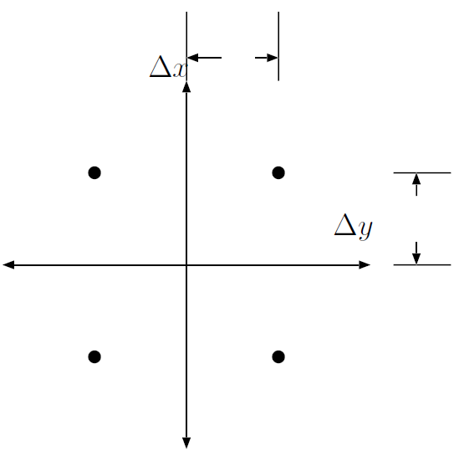
Figure 1. Schematic of the OSSM method for computing a random walk.

The GNOME Method
The General NOAA Operational Modeling Environment (GNOME) method computes a $Δx$, $Δy$ from an input diffusion coeffcient, and at each diffusion time-step, chooses a dx and dy randomly from a uniform distribution, such that $-Δx≤dx≤Δx$ and $-Δy≤dy≤Δy$. As with OSSM, $Δx=Δy$. This results in a distribution that looks like Figure 2. The variance of this distribution is Equation 10
Equation 10. Variance of the distribution computed using the GNOME method.
$$σ_{x}^{2}=\int_{-Δx}^{Δx}{\frac{x^{2}}{2Δx}dx}=\frac{Δx^{2}}{3}$$
and similarly for $σ_{y}^{2}$. From Equation 7, Equation 11 then follows.
Equation 11. Displacement in the x and y directions resulting from the GNOME diffusion method.
$$Δx=\sqrt{6D_{x}Δt}\text{ and }Δy=\sqrt{6D_{y}Δt}$$

Experimental Results
Just to check all this math, I did a few computational experiments. I computed the movement of a bunch of LEs using the above random walk approaches, and compared the results to LEs computed from the analytical solution. They all match pretty well.
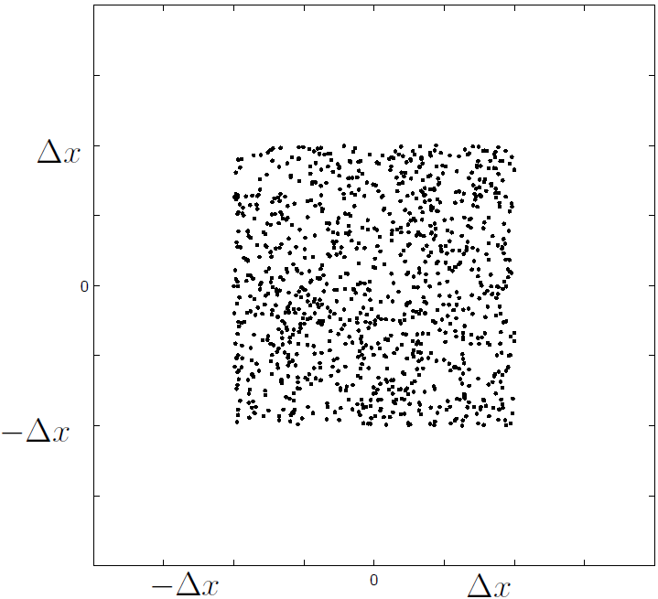
Figure 2. Schematic of the GNOME method for computing a random walk.
In each of the figures (Figure 3 to Figure 6) the top three plots are a picture of the LEs themselves, and the bottom three plots are the cumulative distribution of the x-coordinate of the LEs, plotted on top of the cumulative distribution of the analytical solution.
After 24 time-steps (Figure 6), the cumulative distribution of all the solutions looks pretty close to the analytical solution. In the OSSM method, the picture of the LEs themselves doesn’t look as smooth, because the LEs have all been moved by multiples of $Δx$, so many of them are on top of one another. When running a complete trajectory, the variable windage will smear out the LEs, so that the results look reasonable.
In the first few time-steps, however, the OSSM solution doesn't look that close to the analytical, but the GNOME solution looks very good even after only two steps (Figure 4).
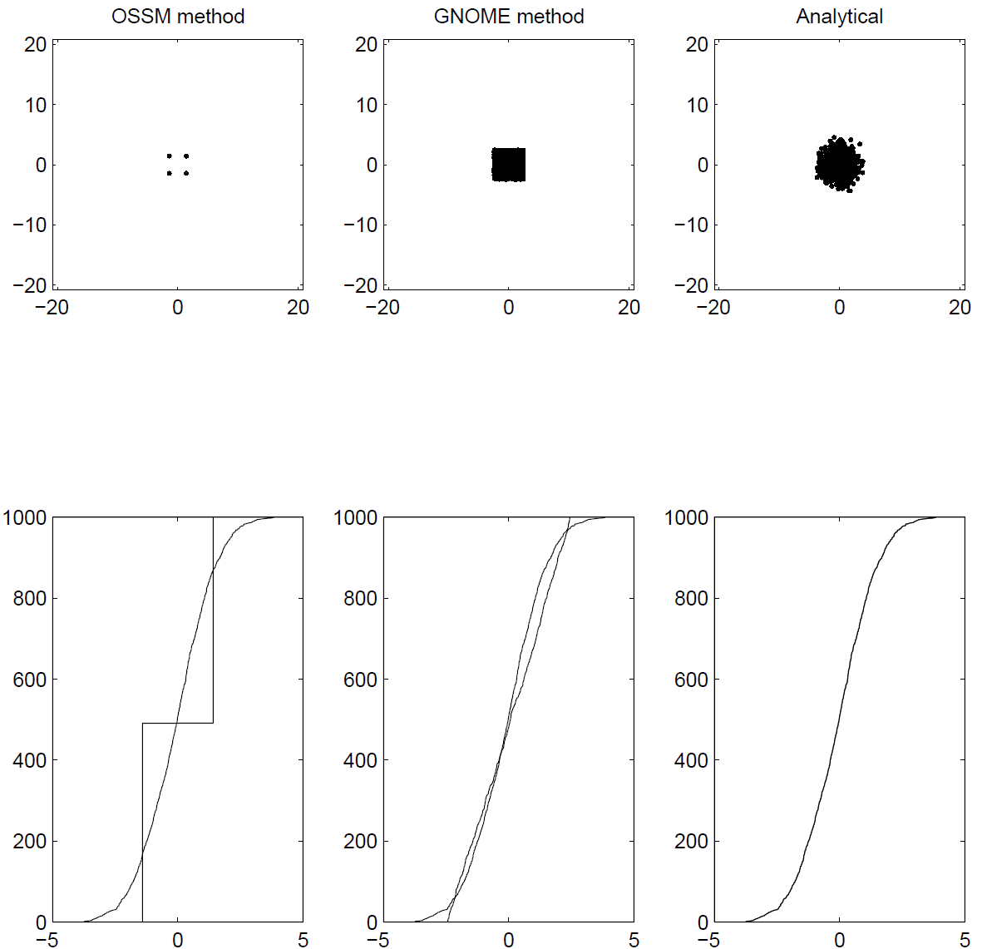
Figure 3. Comparison of results of computing a random walk after 1 step.
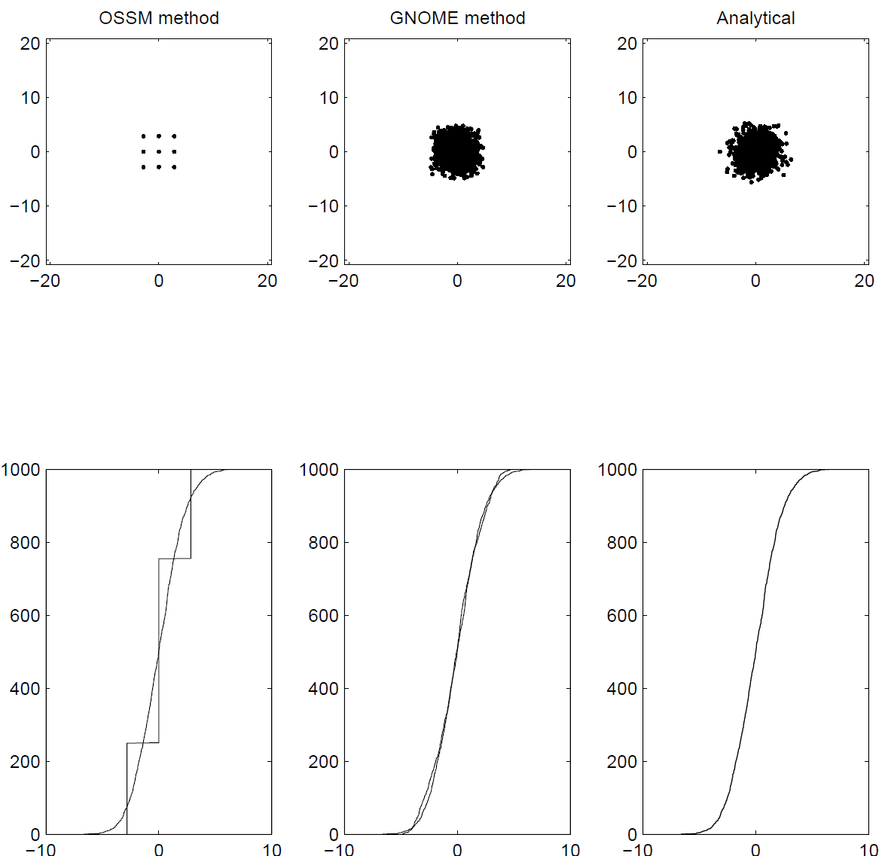
Figure 4. Comparison of results of computing a random walk after 2 steps.
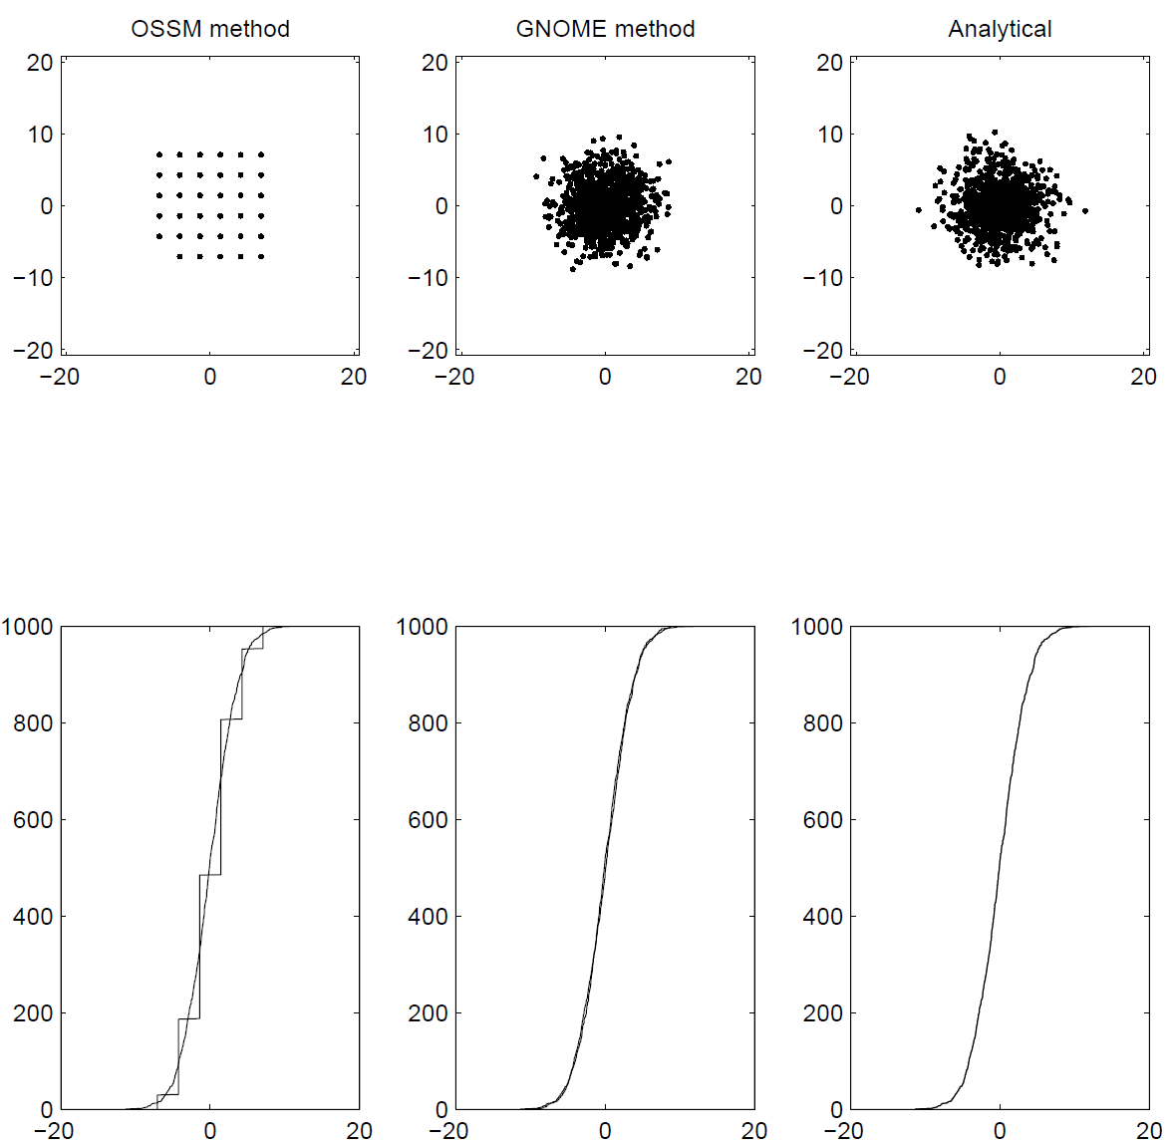
Figure 5. Comparison of results of computing a random walk after 5 steps.
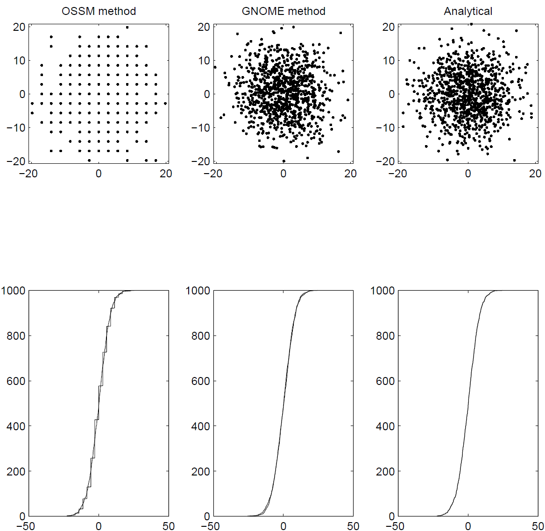
Figure 6. Comparison of results of computing a random walk after 24 steps.

Actual Model Results
The previous test tested how the algorithms in the models work, but as a final test to make sure the actual model output is correct, I ran both OSSM and GNOME with only diffusion, and compared the resulting LE files.

What the Code is Supposed to Do
I took a look at the OSSM code, and consulted with Glen “Bushy” Watabayashi, and OSSM is written to implement the algorithm outlined above, but with $Δx$ computed as Equation 12.

Equation 12. Displacement in the x direction as computed in OSSM.
$$Δx=\sqrt{D_{O}Δt}$$
I’m calling D the OSSM diffusion coefficient.
GNOME uses the algorithm outlined above, with $Δx$ computed as in Equation 11. The result is Equation 13,
Equation 13. Relationship between OSSM and GNOME diffusion coefficients.
$$D_{O}=2D$$
where D is the familiar diffusion coefficient from the diffusion equation, and the one used in GNOME.

The Model Results
Figure 7 to Figure 10 are the results of the model runs, compared to the analytical solution. The diffusion coefficient for these runs was 1×10⁵ cm² s⁻¹. The time-step was 1 h for both the model and the diffusion (The two time-steps have to be the same for GNOME. In OSSM, the diffusion time-step can be shorter). Figure 11 is the variance and standard deviation of the X position of the LE locations for the GNOME and OSSM output, compared to the analytical solution. It is clear from these figures that the OSSM is under-predicting the spread of the LEs.
Figure 12 to Figure 15 are the same figures, but with the diffusion coefficient corrected in the GNOME and analytical solutions, according to Equation 13, setting D to 5×10⁴ cm² s⁻¹.
Clearly the results are now essentially the same.
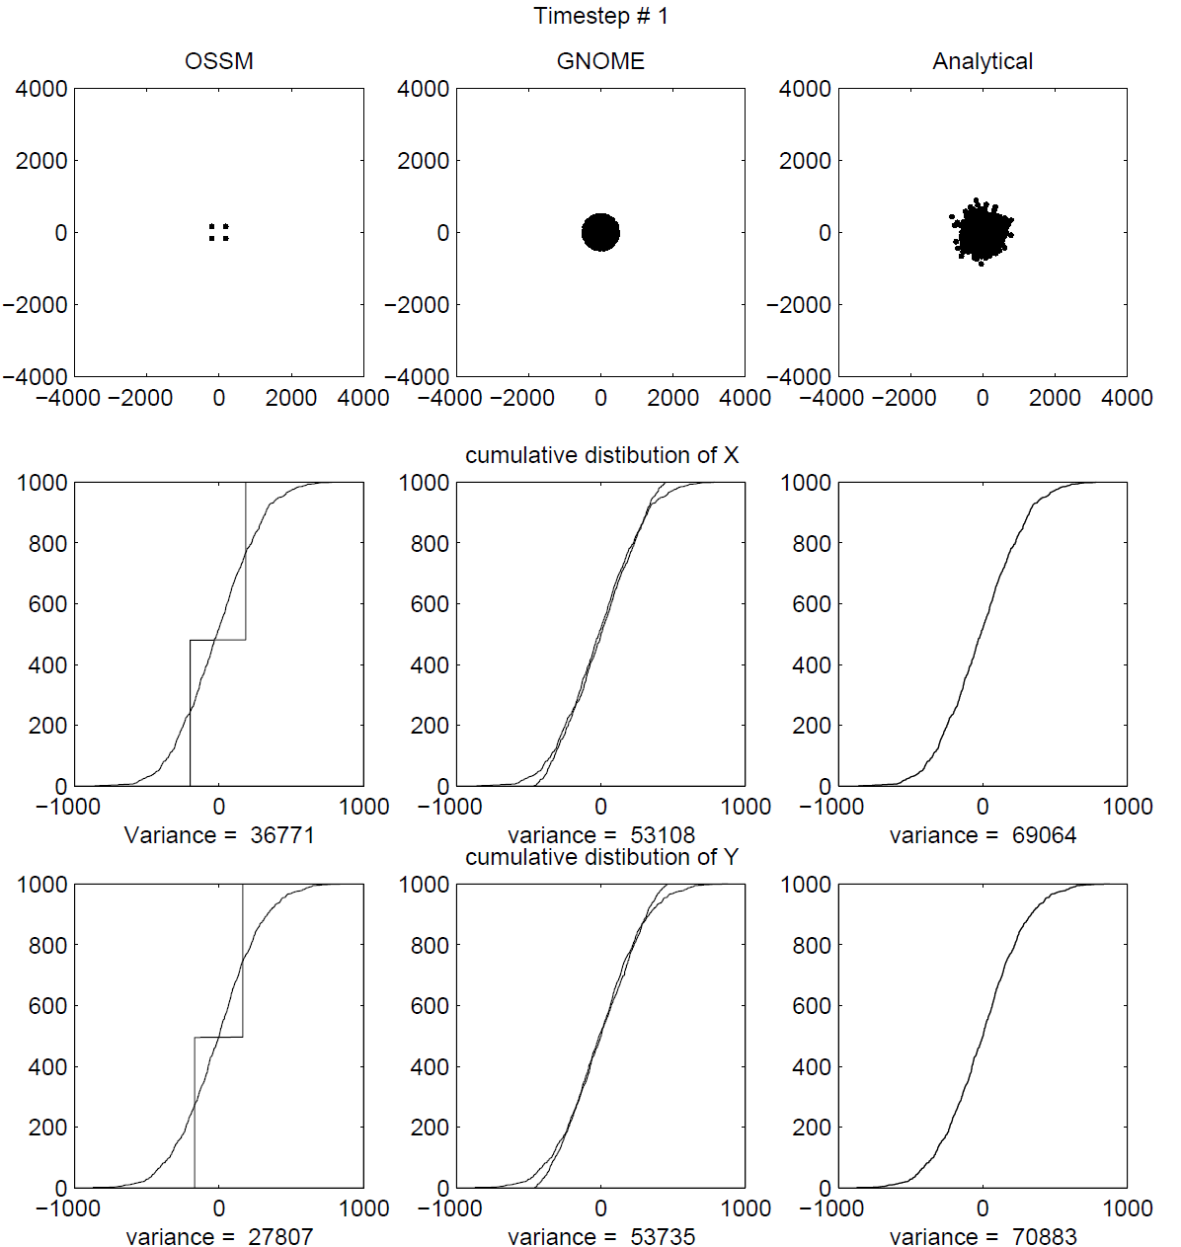
Figure 7. Comparison of results of OSSM and GNOME after 1 step.
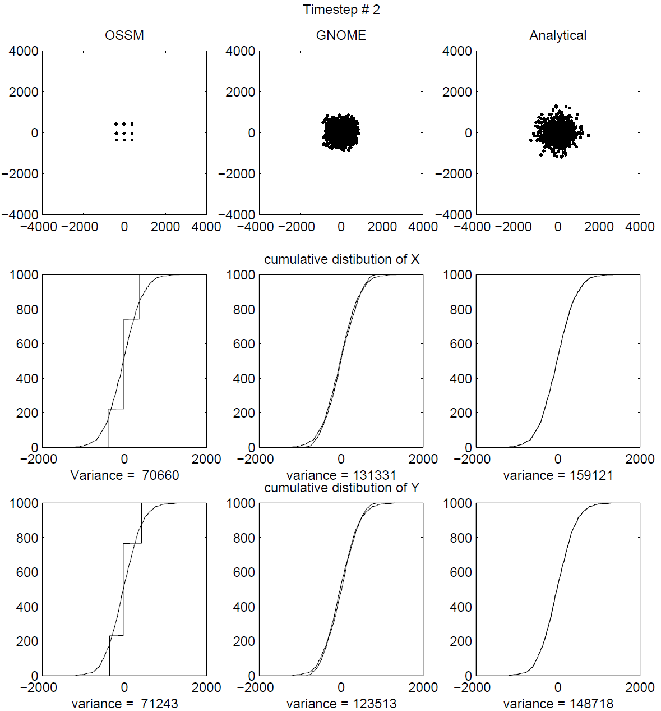
Figure 8. Comparison of results of OSSM and GNOME after 2 steps.
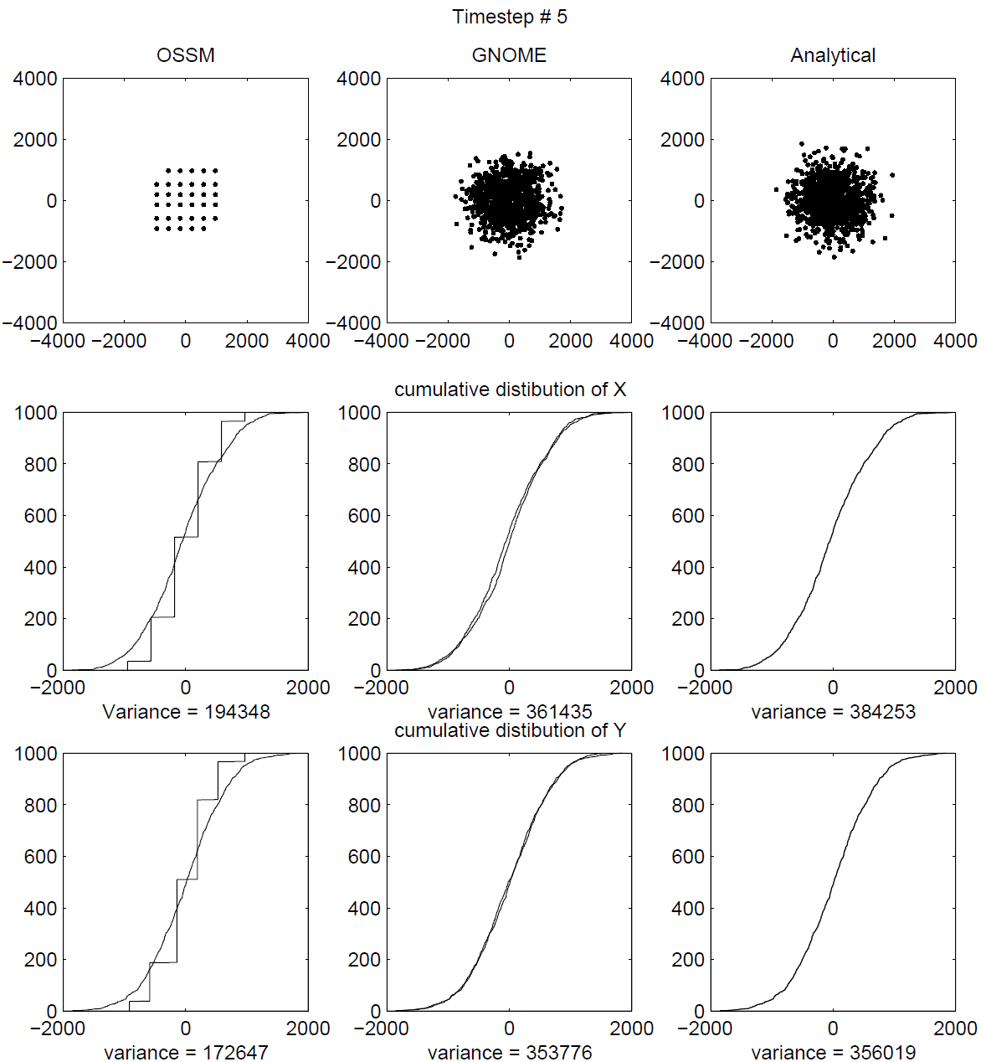
Figure 9. Comparison of results of OSSM and GNOME after 5 steps.
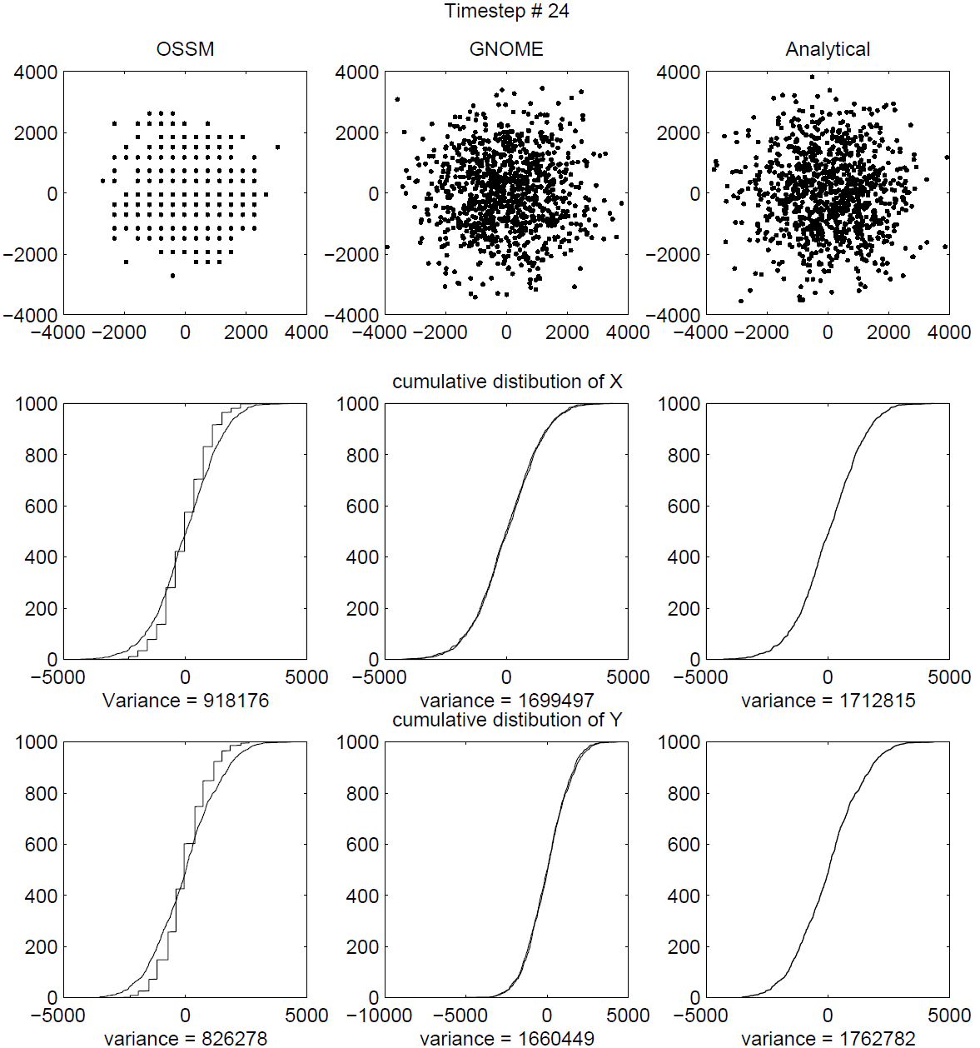
Figure 10. Comparison of results of OSSM and GNOME after 24 steps.
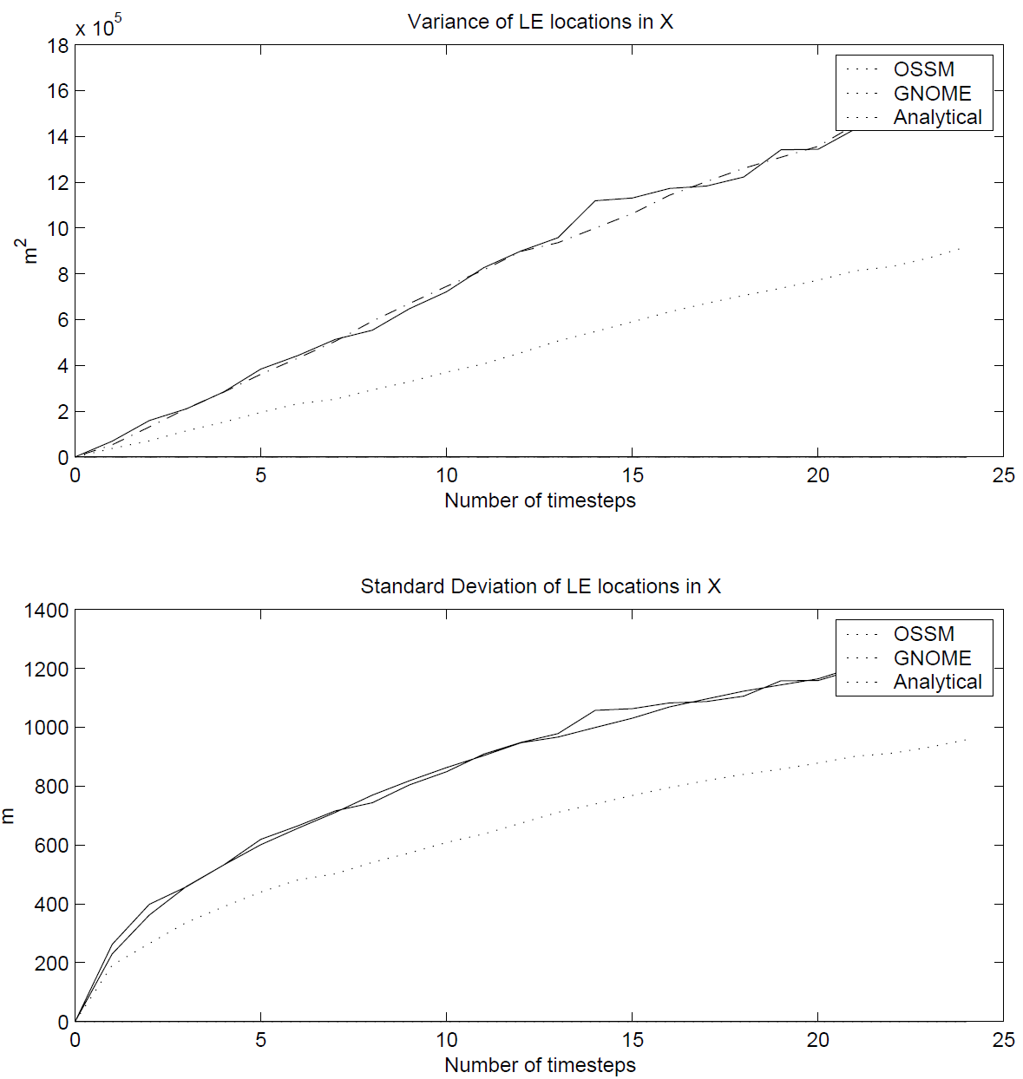
Figure 11. Comparison of the variance and standard deviation of the X position of the LEs from OSSM, GNOME and analytical solutions.
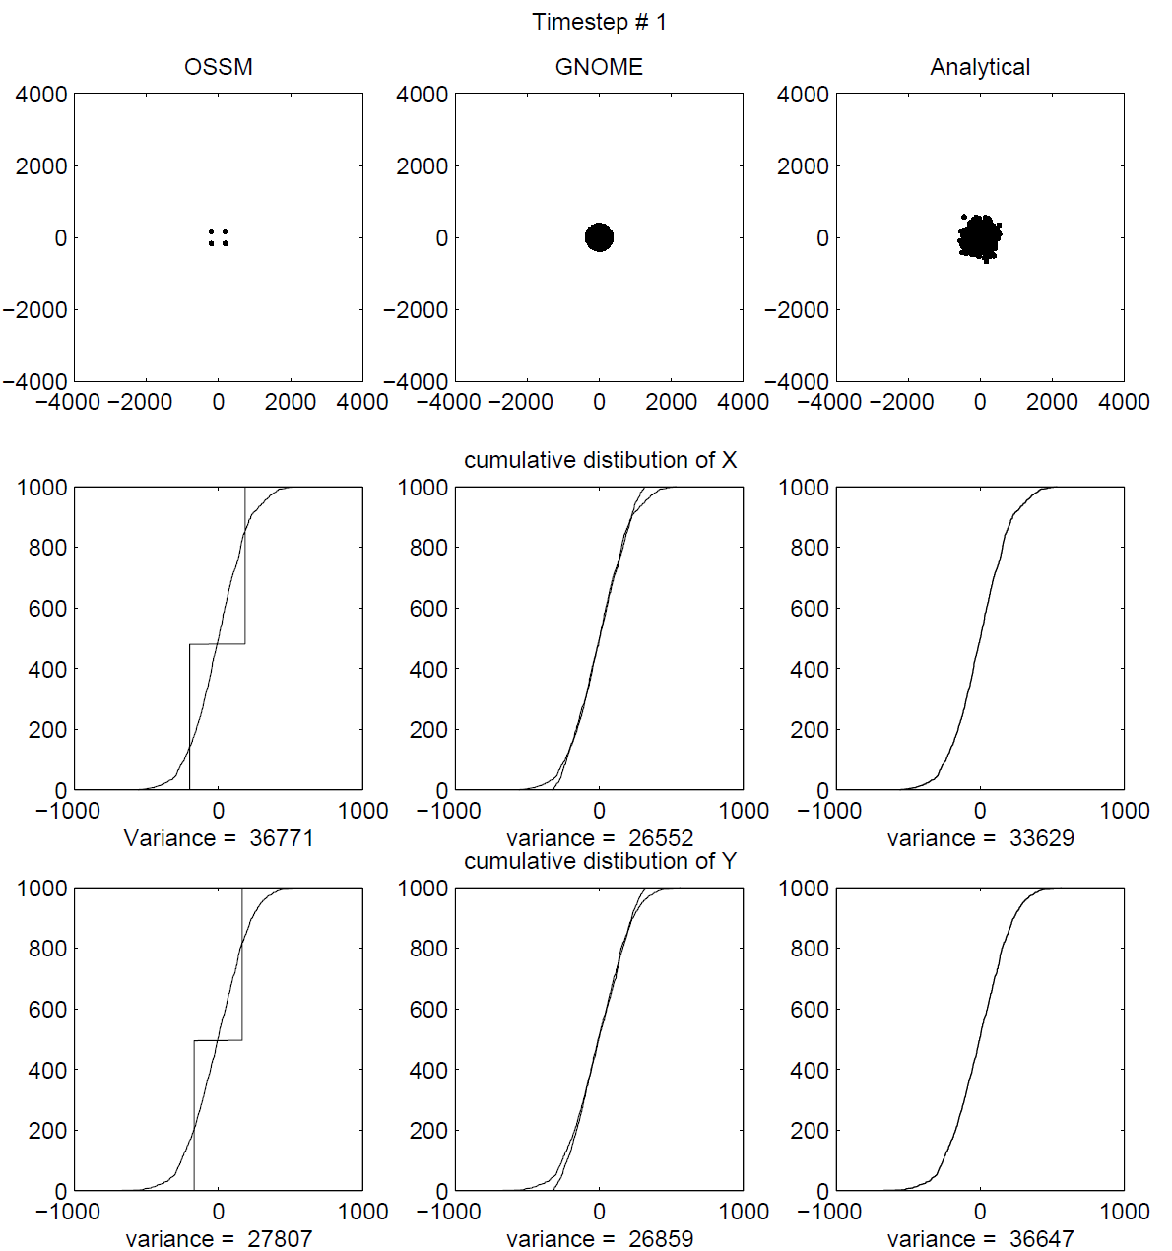
Figure 12. Comparison of results of OSSM and GNOME after 1 step, with the GNOME D corrected to match the OSSM D.
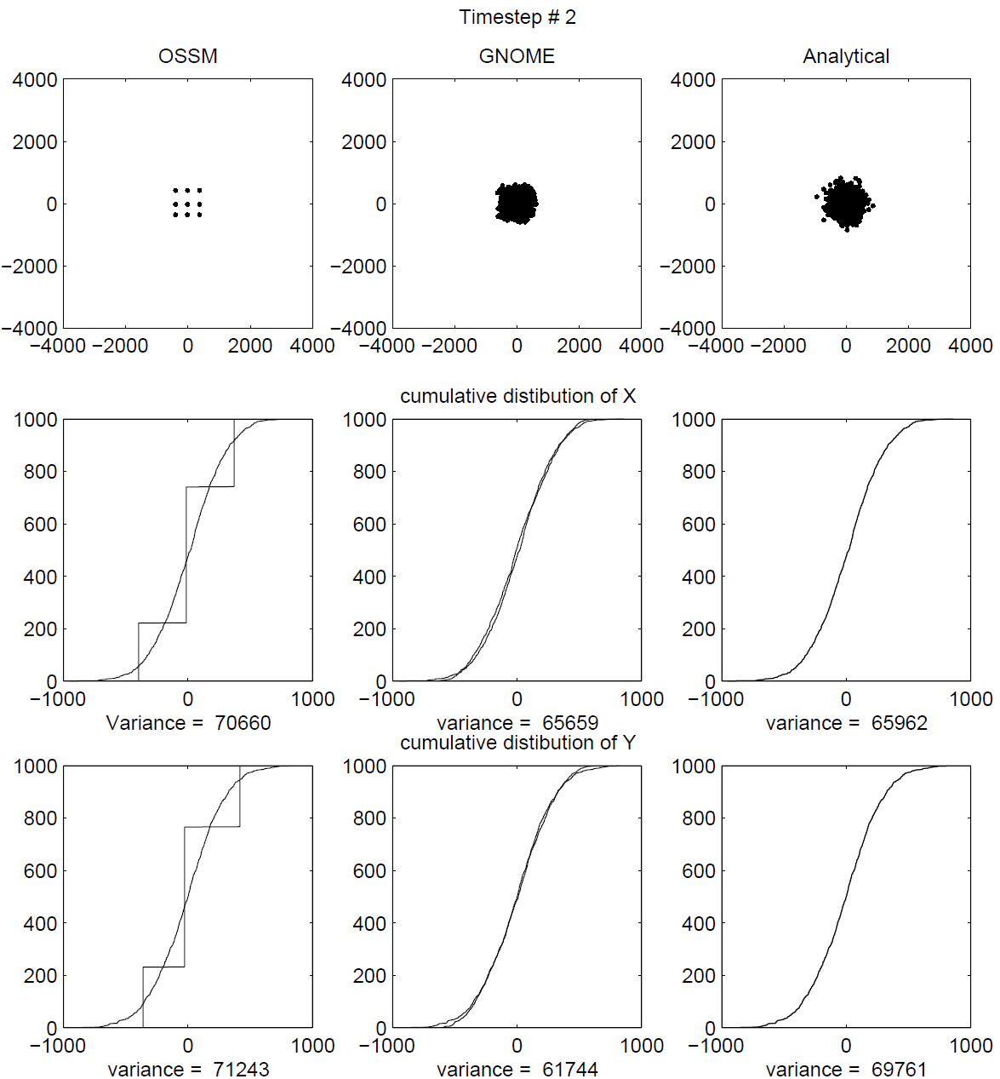
Figure 13. Comparison of results of OSSM and GNOME after 2 steps, with the GNOME D corrected to match the OSSM D.
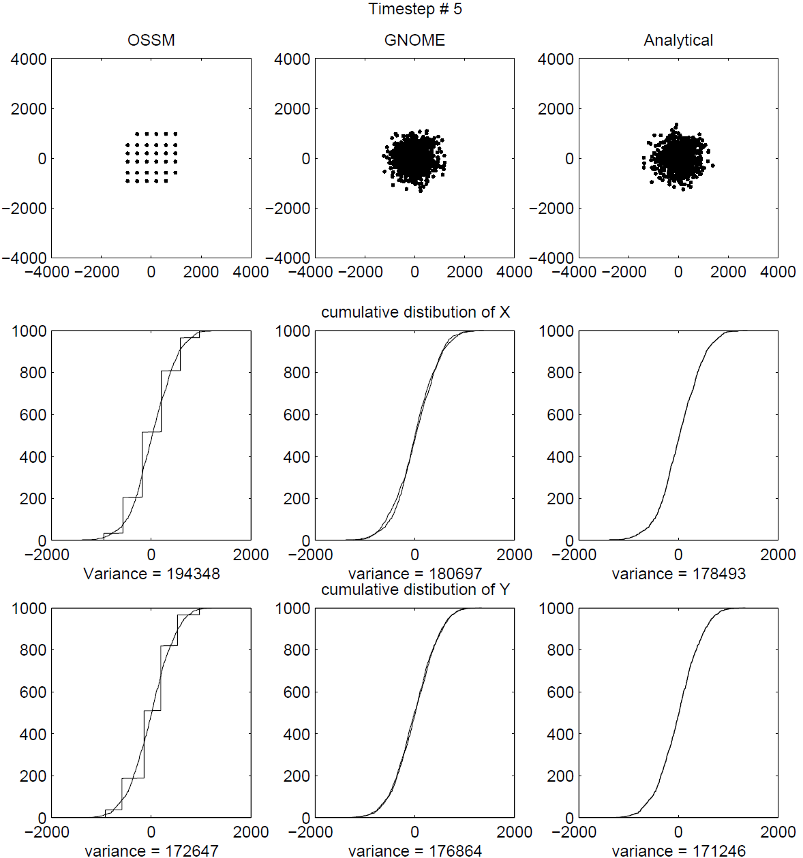
Figure 14. Comparison of results of OSSM and GNOME after 5 steps, with the GNOME D corrected to match the OSSM D.
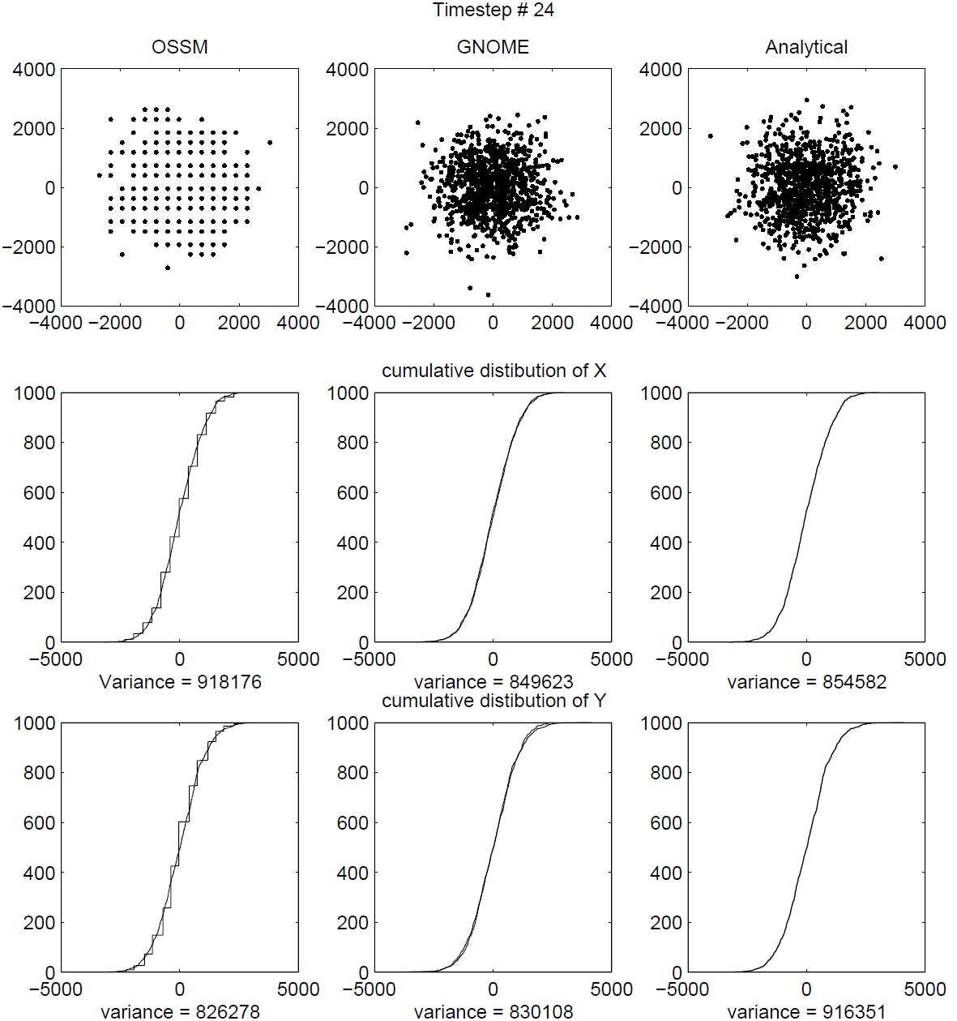
Figure 15. Comparison of results of OSSM and GNOME after 24 steps, with the GNOME D corrected to match the OSSM D.
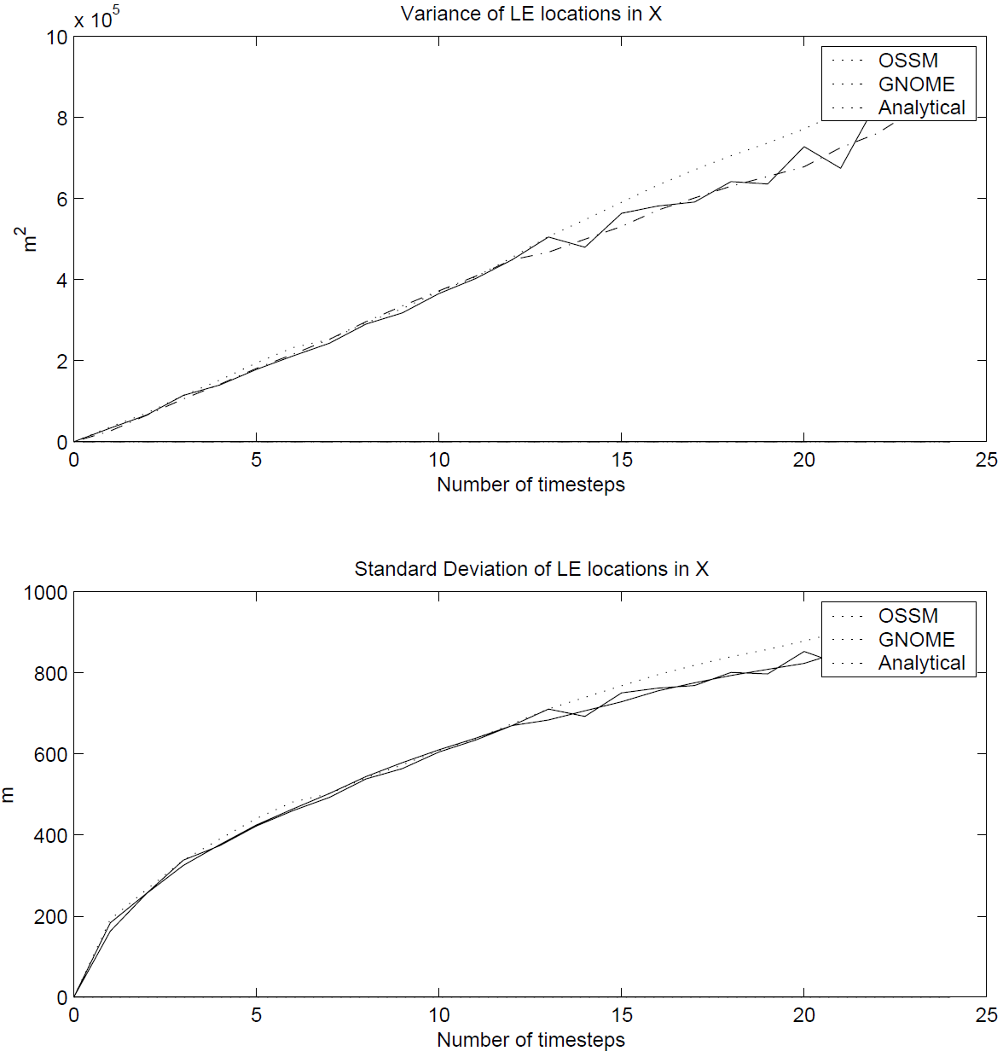
Figure 16. Comparison of the variance and standard deviation of the X position of the LEs from OSSM, GNOME and analytical solutions, with D corrected in GNOME and analytical solutions to match the OSSM solution.

Complications
After running these experiments, it appeared that the conflict between GNOME and OSSM diffusion was resolved. Unfortunately, after running more experiments, another discrepancy was discovered. The source of the problem is that OSSM allows the diffusion time-step and the model time-step to be set independently, so the model time-step is not necessarily an integer multiple of the diffusion step. The diffusion code has some tricks to correct for this. The result of that code, however, is to change the effective diffusion coefficient under certain circumstances. This is the relevant OSSM code:

C This routine is called once every computational time step for each LE.

SUBROUTINE DODIFF(UDIF,VDIF,ALAT,JNMAP)
INCLUDE "Run.inc"
INCLUDE "Diff.inc"
INCLUDE "IO.inc"
Real*4 displacement

C NDIFST is the number of diffusion steps per hour
C XINT is the computational time step in hours
C ADIF is the random displacement every diffusion time step
C UDIF is the X net displacement
C VDIF is the net Y displacement

UDIF=0.0
VDIF=0.0
IF(NDIFST.EQ.0) GOTO 999

C Note here that NTIMES is the computational time step rounded down to
C integer hours
C If it is less than 1, then it is set to 1.

NTIMES=INT(ABS(XINT))
IF(NTIMES.LT.1) NTIMES=1

C This is the displacement per diffusion step scaled by the computational
C time step divided by the rounded time-step. If your computational time
C step is in whole hours, then displacement = ADIF. If your computational
C time step is less than an hour then XINT/NTIMES = XINT.

displacement = ADIF*XINT/NTIMES

C The outer loop is the number of hours your computational time step is
C with a minimum of 1.
C The inner loop is the number of diffusion steps per hour.

DO 150 I=1,NTIMES

C Note that we ALWAYS loop through NDIFST times.
C This is the number of steps per hour even if your computational
C time step is less than 1 hr. displacement was calculated to
C compensate by scaling down the displacement by XINT/NTIMES

DO 100 K=1,NDIFST
AEW=1
ANS=1
R1=RANF()
R2=RANF()
IF(R1.GT.0.5) AEW=-1.0
IF(R2.GT.0.5) ANS=-1.0
UDIF=UDIF+AEW*displacement
VDIF=VDIF+ANS*displacement
100 CONTINUE
150 CONTINUE

C We now convert from km to lat and long degrees and return.
UDIF=XEW(UDIF,ALAT,JNMAP)
VDIF=YNS(VDIF,JNMAP)
999 RETURN
END
The code is well commented, but I’ll summarize it here. This routine is called once for each LE, for each model time-step. The diffusion time-step is defined as “steps per hour” (NDIFST), so the OSSM time-step is truncated to integer hours. This would set the time-step to zero if it started at less than one hour, so it is rounded up to 1 hour. This ensures that the defined number of steps per hour is in fact the minimum number of diffusion steps per OSSM step.
Since the code has changed the diffusion time-step, it must also change the displacement step to compensate. This is done with the line:
displacement = ADIF*XINT/NTIMES

Unfortunately, this compensation is incorrect, and the result is a change in the resulting diffusion, so that the spreading predicted by OSSM is a function of the input diffusion coefficient, and both the model and diffusion time-steps.
From Equation 9, $Δx$ is proportional to the square root of the time-step, so the displacement should be adjusted by the square root of the ratio of new time-step to the old time-step:
displacement = SQRT(ADIF*XINT/NTIMES)

Glen Watabayashi has decided that, in the interests of not breaking old save files, this code will stay the same, and this correction will not be added. A new “GNOME compatible” mode will use the same algorithm as GNOME, except that it will still allow a smaller diffusion time-step than model time-step. The resulting spreading will match the analytical solution, regardless of chosen time-steps (within numerical limits).

The Corrections
If anyone ever wants to match GNOME output to OSSM output that uses the old algorithm, these are the corrections required for the diffusion coefficient:
- If the OSSM model time-step, $Δt_{O}$, is an integer number of hours Equation 14 results;
Equation 14. Correction to the diffusion coefficient when the OSSM model time-step is an integer number of hours.
$$D=\frac{D_{O}}{2}\text{ or }D=\frac{{\left(Δx_{O}∙1×{10}^{5}\right)}^{2}}{2∙Δt_{D}∙3600}$$
the same correction as presented before, where D is the OSSM diffusion coefficient, $Δx_{O}$ is the diffusion displacement step saved and displayed by OSSM (in km), and $Δt_{D}$ is the OSSM diffusion time-step (in h), and the numbers convert the result to cm² s⁻¹.
- If $Δt_{O}$ is less than one hour Equation 15 results.

Equation 15. Correction to the diffusion coefficient when the OSSM model time-step is less than one hour.
$$D=\frac{D_{O}∙Δt_{O}}{2}\text{ or }D=\frac{{\left(Δx_{O}∙1×{10}^{5}\right)}^{2}∙Δt_{O}}{2∙Δt_{D}∙3600}$$
($Δt_{O}$ in hours).
- If $Δt_{O}$ is greater than one hour Equation 16 results,
Equation 16. Correction to the diffusion coefficient when the OSSM model time-step is greater than one hour.
$$D=\frac{D_{O}∙Δt_{O}}{2∙\text{floor}\left(Δt_{O}\right)}\text{ or }D=\frac{{\left(Δx_{O}∙1×{10}^{5}\right)}^{2}∙Δt_{O}}{2∙Δt_{D}∙3600∙\text{floor}\left(Δt_{O}\right)}$$
where the floor() function rounds down to the nearest integer hour.

Conclusions
- Diffusion can be simulated in a Lagrangian element model by a random walk, with virtually any distribution for the random steps taken. Whatever distribution is used, the variance of that distribution should be Equation 17,
Equation 17. Variance for whatever distribution is to be used to simulate diffusion.
$$σ^{2}=2DΔt$$
where D is the diffusion coefficient in the diffusion equation, which is equal to the eddy diffusivity in a turbulent diffusion model.
- Both the GNOME and OSSM methods work well, with GNOME’s method giving results closer to the analytical solution in fewer time-steps.
- The diffusion coefficient used in GNOME is the same one users are familiar with from the diffusion equation.
- The diffusion coefficient used in OSSM is different than that used in GNOME, and the effective diffusion is a function of both OSSM time-step and the diffusion time-step. The effective diffusion coefficient for integer-hour OSSM time-steps is one half the input coefficient. For non-integer-hour OSSM time-steps, the effective coefficient can be computed from the formulas given in §5.4.

References
Csanady, G. T. (1973). Turbulent Diffusion in the Environment. Dordrecht, Holland: D. Reidel Publishing Co.

Appendix C

LE Windage Math
Christopher H. Barker, 2001

Table of Contents
List of Equations 97
1 Background 99
2 Computation 99
2.1 The Problem 99
2.2 The Solution 100
2.2.1 The Math 100

List of Equations
Equation 1. Amount of spreading from windage. 99
Equation 2. Variance of LEs from windage over time. 99
Equation 3. LE spreading by wind resulting from the OSSM and GNOME methods. 100
Equation 4. Spreading coefficient resulting from a uniform distribution. 100
Equation 5. Spread for the actual time-step (should) equal the same as for the reference time-step. 101
Equation 6. The mean windage equals the mean reference windage. 101
Equation 7. The range of windage values is a function of the square root of the ratio of the reference time-step to the actual time-step. 101
Equation 8. The minimum windage, A, and maximum windage, B. 101

LE Windage Math
Christopher H. Barker, January 10, 2001

Background
For many years at HAZMAT, we have described the movement of oil by wind in terms of factors like: “1% to 4% of the wind speed.” This is based on a combination of an analytically derived factor of 3% of wind speed, and the empirical observation that oil tends to spread out in the direction of the wind. After a lot of experimentation and observation, using 1%-4% with OSSM seemed to work pretty well, and could be adjusted when overflights indicated that the oil was spreading in the direction of the wind either more or less that the model runs predicted.
As a way of explaining the physics of this phenomenon, we can say that a given oil droplet is, in fact, being pushed up and down from the actual surface of the water by wave action, etc., so it will move faster and slower depending on how close the surface it is at any given moment.

Computation
In order to compute the windage, both the On-Scene Spill Model (OSSM) and General NOAA Operational Modeling Environment (GNOME) pick a random number between the range of windage values for each Lagrangian element (LE), and move it according to that number at each time-step. The result is that the LEs spread out in the direction of the wind. This method is very similar to the method used to compute diffusion, except that the spreading happens only in the direction of the wind. The amount of spreading is given by Equation 1,
Equation 1. Amount of spreading from windage.
$$\frac{dσ^{2}}{dt}=S\left(t\right)$$
where $σ^{2}$ is the variance of the LEs locations, and S(t) is a spreading parameter that is a function of time, because the wind velocity is a function of time. For a constant wind, S would be constant and Equation 2 would follow:
Equation 2. Variance of LEs from windage over time.
$$σ^{2}=St$$
that is, the variance of the particles grows linearly in time, the same as diffusion with a constant diffusion coefficient.

The Problem
With the algorithm used by OSSM and GNOME, at any given time-step you have Equation 3:
Equation 3. LE spreading by wind resulting from the OSSM and GNOME methods.
$$S=\frac{ΔW^{2}∙U^{2}∙Δt}{3}$$
where $ΔW$ is the range of the windage parameters, and U is the wind velocity at that time-step. What should be immediately apparent from Equation 3 is that the degree of spreading is a function of both the wind speed (which it should be) and the time-step, which it should not. Experiments with GNOME have demonstrated that the spreading does, indeed, vary with time-step.
Why is this the case? If we explain the physics as above, imagining that any given particle is moved from the surface, and travels at a slower speed for a while, and then moves back up, and travels at a faster speed, the time-step is the persistence of this process. That is, the amount of time a given particle spends traveling at a given velocity. If you imagine the extremes:
- infinite persistence would have each particle moving at a different speed, and keeping that speed the entire time, resulting in a lot of spreading, and
- infinitely short persistence would have each particle varying its speed constantly between the extremes, resulting in all the particles moving at the mean velocity, resulting in no spreading.
We decided at a GNOME development meeting that this was a “bad thing”, and that we should fix it. As much as possible, a model should behave the same when the time-step is changed.

The Solution
The closest way to describe what we are doing is in terms of persistence. GNOME could be given a range of windage percentages, and a persistence time-step, and then move the LEs appropriately to get the desired amount of spreading. This would be almost the same as what we have always done, specifying a windage range, and the persistence could either be fixed at an appropriate number (currently GNOME often defaults to a time-step of 0.25 hours), or it could be adjusted by the user (maybe only in Diagnostic mode?).

The Math
Now, on to the math.
We are using a uniform distribution at each time step, so the resulting spreading coefficient, S is given by Equation 4,
Equation 4. Spreading coefficient resulting from a uniform distribution.
$$S=\frac{Δx^{2}}{3Δt}$$
where $Δx$ is the range of distances over which the LEs are distributed. This is computed by multiplying the windage by the wind speed, resulting in Equation 3.
If the reference windage is defined as being from A to B times the wind speed, with a persistence of $Δt_{0}$, we have $ΔW_{0}=B_{0}-A_{0}$ and the mean windage, $\overline{W_{0}}=\frac{B_{0}+A_{0}}{2}$. From Equation 3 we want S to be constant, so we can compute the values for a given time-step from Equation 5:
Equation 5. Spread for the actual time-step (should) equal the same as for the reference time-step.
$$\frac{ΔW^{2}∙U^{2}∙Δt}{3}=\frac{ΔW_{0}^{2}∙U^{2}∙Δt_{0}}{3}$$
and Equation 6,
Equation 6. The mean windage equals the mean reference windage.
$$\overline{W}=\overline{W_{0}}$$
so thus Equation 7,
Equation 7. The range of windage values is a function of the square root of the ratio of the reference time-step to the actual time-step.
$$ΔW=ΔW_{0}\sqrt{\frac{Δt_{0}}{Δt}}$$
and then Equation 8,
Equation 8. The minimum windage, A, and maximum windage, B.
$$A=\overline{W}-\frac{ΔW}{2} \\ B=\overline{W}+\frac{ΔW}{2}$$
If we use the new A and B in the same code as before, all should be well.

Formerly the Hazardous Materials Response Division (HAZMAT).
GOODS was developed to help GNOME users access ocean currents or winds from various models and data sources.
From http://response.restoration.noaa.gov/gnomelocationfiles
This limit applies to GNOME’s 2-D mode; in its limited pseudo 3-D mode, there is no threshold on the number of LEs.
Exceptions: For the cases of ANCHORAGE, CALETA PERCY, DAEHUKSAN DO, LISBON, MUKHO HANG, and SOKCHO HANG, there are more than 37 constituents.
Exceptions: For the cases of ANCHORAGE, CALETA PERCY, DAEHUKSAN DO, LISBON, MUKHO HANG, and SOKCHO HANG, there are more than 37 constituents.
Appendix G of this report provides samples of five trajectory analysis files; samples 3-5 correspond to the above descriptions of File 3, File 4, and File 5.
Available at http://response.restoration.noaa.gov/oil-and-chemical-spills/oil-spills/response-tools/gnome-location-files-and-associated-resources.html

